BUSINESS ECONOMICS - ANTONIO GINÉS - 1/112
PART 1.- THE PRODUCTION AREA.-
- PRODUCTIVE PROCESS, EFFICIENCY AND PRODUCTIVITY.-
  - Definition of production.- Production is a process of combining various material inputs (things) and immaterial inputs (plans, knowledge) to make something for consumption (output).
  - Classification of productive activities.-
    - According to the segment where the product is directed.-
      - Production by order.- The product has been manufactured because the client has ordered it
      - Production for the market.- The product has been manufactured for the market in general.
    - According to the degree of differentiation of the product.-
      - Series production.- All products are the same
      - Individualized production.- Each product is different
    - According to the continuity of the production process.-
      - Continuous process.- The activity doesn’t stop
      - Discontinuous process.- The activity ends with the manufacture of the product and begins again when we make another product (eg the construction of an industrial unit)
  - Allocation of productive resources.-
    - Production factors. Evolution of the concept.-
      - Classical economists.- They use the three factors that Adam Smith defined, each factor takes part in the result of production through a reward set by the market:
        - Land (which is rewarded by rent)
        - Work (which is rewarded by wage)
        - Capital (which is rewarded by interest)
      - Neoclassical economists.- They use only capital and labor
      - Current economy.-
        - Earth.- (More and more changed by human intervention). Today the land is considered a component of capital or a component of a broader natural factor (natural resources or natural capital)
        - 4th factor of production.- In the economy of knowledge and business development produced since the end of the 20th century, people consider that technology and science (what has been called R + D - Research and Development - or even R + D + i –Research, Development and Innovation-) is a 4th factor of production that characterizes more and more production in industrialized countries. At the same time, to the concept of physical capital or financial capital is added the concept of human capital or intellectual capital, even social capital, as a way of explaining the improvement in productivity that isn’t due to the other factors.
        - New factors of production.-
          - Natural capital
          - Physical capital
          - Material work
          - Intangible capital (knowledge, organization, non-physical but computable assets, intangible work, knowledge economy)
        - Training.- Investment allows the volume of production factors to increase. Training can be considered a form of investment, because it increases the capacities of workers and production
  - Relationship between families and companies.-
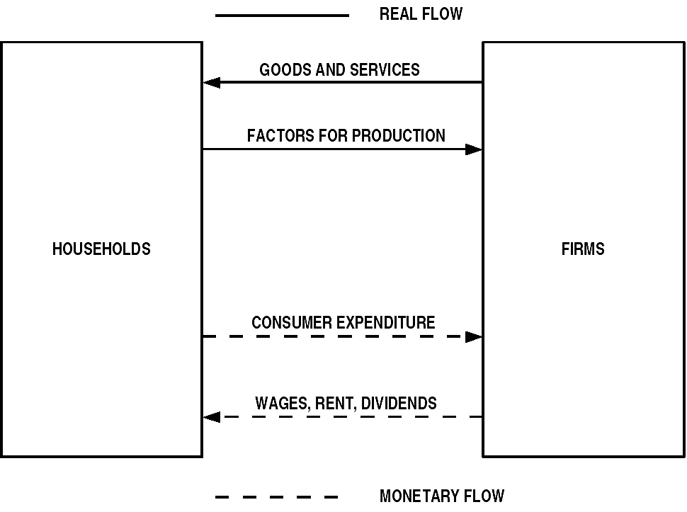
  - Relationship between families and companies and the public sector.-
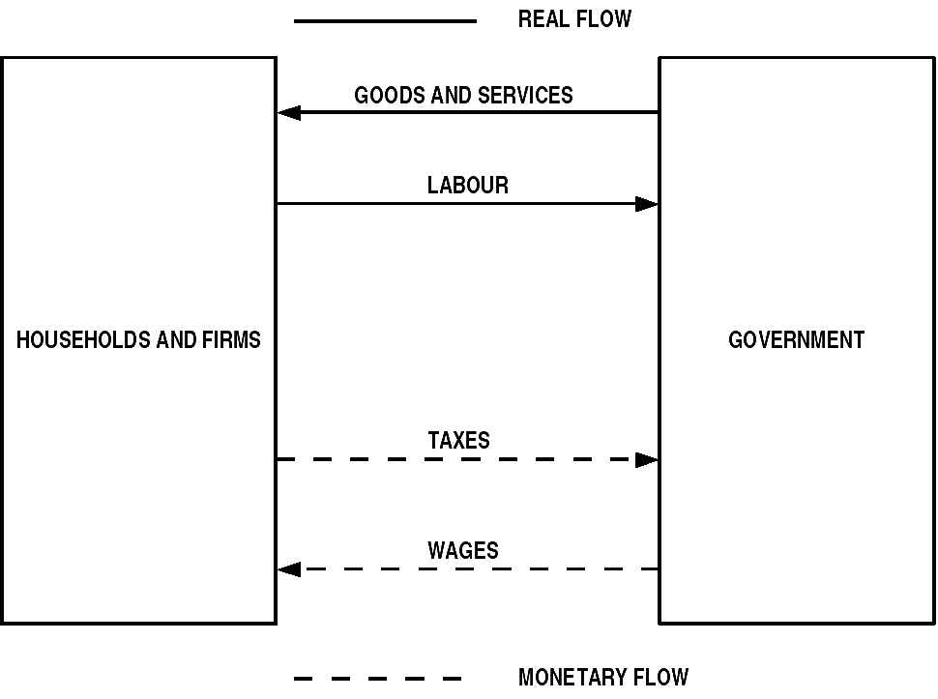
  - Productivity of a factor.- Productivity of a factor = Quantity produced of a product : Incoming quantity of a factor
    - Example.- Calculate labor productivity if the company needs 20 man/hours to produce 100 chairs
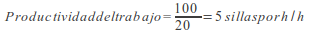
  - Global productivity.-
    - Restrictions.-
      - As we refer to all production, where different types of products can exist, and to all factors, we can’t work only with quantities, but we must mix them, in monetary terms, through their prices.
      - Normally, we compare the productivities of different years so we must use constant prices (the prices of the base year) to avoid inflation.
    - Example.-

 | 2009 |  | 2010
Outputs | Quantity | Price | Quantity | Price
Chairs | 100 | 24 | 120 | 25
Tables | twenty | 36 | fifteen | 38
Inputs | Quantity | Price | Quantity | Price
Work | 100 | 18 | 90 | 19
Wood | 700 | 0.9 | 650 | 1

      - Overall productivity for the base period.-
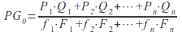
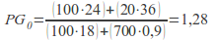
      - Global productivity for the next period.-
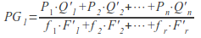
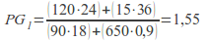
      - Global productivity index.-
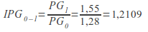
      - Global productivity rate.-
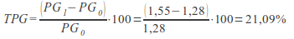
  - Project management model; PERT.-
    - PERT model.-(click here to learn more about PERT)
      - Functioning.-
        - Critical path.- The PERT describes the critical path. It’s the path that takes the longest time to complete. In this path we can’t admit delays.
        - Several.- It’s possible to have several critical paths

ACTIVITIES | DESCRIPTION | MINUTES | PLACES
- | - | - | 1. Start
A | Wash the lettuces | 1 | 2. Sink 1
B | Wash the tomatoes | 1 | 3. Sink 2
C | Chop the lettuces | 3 | 5. Countertop
D | Chop the tomatoes | 4 | 5. Countertop
E | Boil the eggs | 8 | 4. Vitroceramic
F | Chop the eggs | 2 | 5. Countertop
G | Dress | 2 | 6. Salad bowl
      - Graph.-
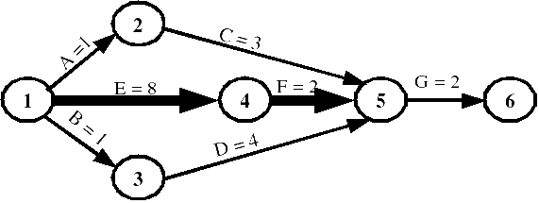
      - Explanation.- In this example, activities A and C admit a delay of six minutes ((8 + 2) - (1 + 3)), because we need the lettuces after cooking and chopping the eggs (which lasts ten minutes). Activities B and D allow a delay of five minutes. Activities E, F and G don’t admit any delay because they’re on the critical path.
      - Critical path.- The critical path is EFG.
      - Duration.- We finish the salad in twelve minutes.
    - Gantt chart.-
      - Precedent.- It’s a precedent of the PERT method.
      - Salad.- The Gantt chart of the salad would be:
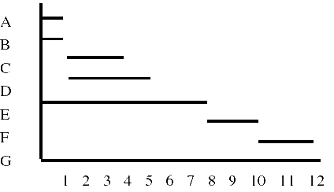
      - Problem.- Activities C and D follow activities A and B but we don’t know if activity C follows activity A or activity B.
      - Six minutes.- This method allows you to know how the process is. So if we want to know how the process is when the time is six minutes:
        - Completed activities: A, B, C and D totally and E (75%)
        - Activities that haven’t started yet: E (25%) and F and G fully
  - Competitiveness and quality.-
    - How can we achieve competitiveness? .- We must achieve the costs that allow us to have good prices, but there’re two problems:
      - The market sets the prices, not the company
      - We can’t reduce costs by reducing quality
    - The quality.-
      - How can we measure it? .- Through the degree of adjustment to the production program and seeing if we have the attribute or attributes that satisfy the needs of consumers in the best way
      - Total quality.- All the departments of the company have the responsibility of achieving quality
      - How can we achieve quality? .- We must establish a standard and we must establish controls
- THE IMPORTANCE OF TECHNOLOGICAL INNOVATION: R + D + i.-
  - 4th factor of production.- In the economy of knowledge and business development produced since the end of the 20th century, people consider that technology and science (what has been called R + D -Research and Development- or even R + D + i –Research, Development and Innovation-) is a 4th factor of production that characterizes more and more production in industrialized countries. At the same time, the concept of physical capital or financial capital is added to the concept of human capital or intellectual capital, even social capital, as a way of explaining the improvement in productivity that isn’t due to other factors.
  - Ways to obtain technology.-
    - We can buy it from other companies or countries.- In this way we depend technologically on others and we can’t develop freely
    - We can discover new technologies.- We need R + D + i departments. These departments are expensive and only large companies can have them
  - The technological matrix.- The technological matrix helps us decide the best technology for our company and also indicates us whether we should buy it or invest in an R + D + i department.
  - Technological innovation, intellectual property and consumer protection.- States create norms that defend technological innovation, that is why states create norms that defend intellectual property
  - Main forms of intellectual property.-
    - Patents.- A patent is a set of exclusive rights granted by the state (the national government) to an inventor or their assignment for a limited period of time (in Spain 20 years) in exchange for a public disclosure of an invention.
    - Utility model.- A utility model is very similar to a patent, but usually has a shorter time (in Spain 10 years) and less strict patentability requirements
    - Trademarks.-
      - Definition.- A trademark is a distinctive sign or indicator used by an individual, a business organization, or other legal entities to identify that the products or services for consumers with which the trademark appears originate from a single source, and to distinguish your products or services from those of other entities.
      - Maintenance.- Trademark rights must be maintained through the current and legitimate use of the trademark. These rights will cease if a trademark isn’t actively used for a period of time, normally 5 years in most jurisdictions (in Spain 10 years).
- BUSINESS COSTS: CLASSIFICATION AND CALCULATION.-
  - Definition of costs.- It’s the value of the production factors that we have been spending to produce something
  - Types of costs.-
    - According to the way in which they are loaded to the project or the product.-
      - Direct costs.-
        - Definition.- They’re those for activities or services that benefit specific projects, eg. salaries for project personnel and materials required for a particular project. Because these activities are easily mapped to projects, their costs are usually charged to projects on an individual basis.
        - Costs usually charged directly.- Project staff, consultants, project supplies, publications, travel, training, etc.
      - Indirect costs.-
        - Definition.- They’re those for activities or services that benefit more than one project. Its precise benefits to a specific project are often difficult or impossible to locate. For example, it can be difficult to determine precisely how the activities of an organization's director benefit a specific project.
        - Costs usually assigned indirectly.- Utilities, rent, audit and legal, administrative staff, rental equipment, etc.
        - Costs either charged directly or assigned indirectly.- Price of phone, computer use, project office staff, postage and printing, assorted office supplies, etc.
      - Direct/Indirect.- It’s possible to justify the treatment of almost any type of cost as direct or indirect. Labor costs, for example, can be indirect, as in the case of maintenance personnel and official executives; or they can be direct, as in the case of project staff members. Similarly, materials such as miscellaneous supplies purchased in bulk - pencils, pens, paper - are typically treated as indirect costs, while materials required for specific projects are charged as direct costs.
    - According to its dependence on the volume of activities.-
      - Fixed costs.- These are business expenses that aren’t dependent on business activities. They tend to be related to time, such as wages or rent paid by the month.
      - Variable costs.- They’re related to volume (and are paid by quantity)
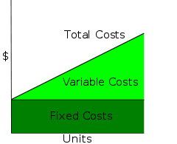
- BREAK EVEN POINT.-
  - Overview.- In economics and business, specifically cost accounting, the break even point is the point where costs or expenses and income are equal: there is no net loss or profit. A profit or loss hasn’t been made, although the opportunity costs have been paid, and the capital has received a risk-adjusted return.
  - Example.- If a business sells less than 200 tables each month, it will make a loss, if it sells more, it will make a profit. With this information, the manager will then need to see if they expect to be able to make and sell 200 tables per month.
  - Graph.-
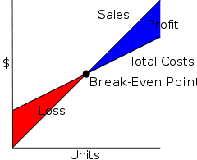
  - Implementation.- If they think they can’t sell that much, to ensure viability they could:
    - Fixed costs.- Try to reduce fixed costs (renegotiating the rent for example, or maintaining better control of telephone bills or other costs)
    - Variable costs.- Try to reduce variable costs (the price you pay for tables by finding a new supplier)
    - Price.- Increase the sale price of your tables.
    - Either.- Any of these would reduce the break even point. In other words, the business wouldn’t need to make as many tables to ensure that it could pay its fixed costs.
  - Calculation.- In the linear model of cost, volume and profit analysis, the break even point in terms of units sold (Q) can be directly calculated in terms of total revenue (I) and total costs (TC) as:
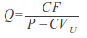
    - where:
      - CF are the fixed costs
      - P is the price of the unit sold, and
      - CVu is the unit variable cost
    - The amount (P - CVu) is of interest in its own right, and is called the Unit Contribution Margin: it is the marginal benefit per unit
- INVENTORIES AND ITS MANAGEMENT.-
  - Inventory costs.-
    - Acquisition and production costs.-
    - Fixed costs of entry into the warehouse.- Transportation costs, order costs, processing, etc.
    - Storage costs.- Warehouse rental, internal movement of goods, control and maintenance
    - Technical costs.-
      - Obsolescence.- Technical obsolescence can occur when a new product or technology replaces the old one, and it becomes preferred to use the new technology instead of the old one. Historical example of replacement technologies causing obsolescence include CD-ROM on floppy disk which allowed for greater storage capacity and speed.
      - Opportunity cost.- It’s the best choice available to someone who has chosen between several mutually exclusive choices
      - Financial cost.- It’s the interest that I have to pay for the loan that I have requested to pay the warehouse
  - The cycle of renovation of the warehouse and the safety stock.-
    - Out of stock.- When we don’t have merchandise
    - S = Order volume
    - T = Replenishment time (time between two orders)
    - S/T = Average depletion of stock (number of units sold per day)
    - Sm= Stock level to place a new order
    - d = Delivery period, in days, used by suppliers = (Sm- Ss): S/T
    - Ss= Safety Stock (allows you to continue working when there’re delays in delivery days)
    - Average warehouse stock = Ss + ½ S
    - Example.- Knowing that the order volume is 500 chairs, the replacement time is five days, the safety stock is 300 chairs and the delivery time used by the suppliers is three days. Calculate: the average stock depletion, the stock level to place a new order and the average stock in the warehouse
    - Solution.-
      - Average depletion of stock = S/T = 500/5 = 100 chairs per day
      - If we sell 100 chairs per day, the delivery time used by the suppliers is three days and the safety stock is 300 chairs; the stock level to place a new order will be: (100 x 3) + 300 = 600 chairs
      - Average warehouse stock = Ss + ½ S = 300 + ½ 500 = 550 chairs
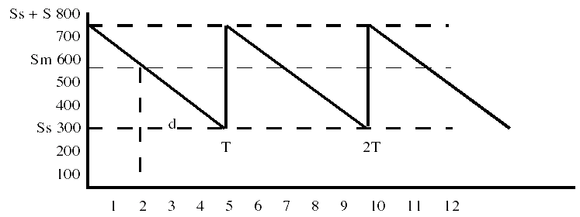
  - Wilson Model.- (click here to learn more about the Wilson Model)
    - Economic order quantity.- It’s the inventory level that minimizes total inventory maintenance costs and order costs.
    - Variables.-
      - Q = order quantity
      - Q * = optimal order quantity
      - D = quantity of annual demand for the product
      - P = purchase cost per unit
      - S = fixed cost per order (not per unit, in addition to unit cost)
      - H = annual cost of ownership per unit (also known as cost of ownership or cost of storage) (warehouse space, refrigeration, insurance, etc. usually not related to unit cost)
    - Formula.-
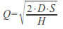
- EXTERNALITIES.-
  - Definition of externality.- An externality (or surplus transaction) is a cost or benefit, not transmitted through prices, incurred by a party that doesn’t agree with the action causing the cost or benefit. A benefit in this case is called a positive externality or external benefit, while a cost is called a negative externality or external cost.
  - Prices don’t reflect the total costs/benefits.- In these cases in a competitive market, prices don’t reflect the total costs or benefits of producing or consuming a product or service, producers and consumers may or may not bear all the costs or not collect all the benefits of economic activity, and too much or too little of the merchandise will be produced or consumed in terms of overall costs and benefits for society. For example, manufacturing that causes air pollution imposes costs on the whole of society, while fire prevention at home improves the fire safety of neighbors.
  - Overproduction/underproduction.- If there are external costs such as contamination, the merchandise will be overproduced by a competitive market, since the producers won’t take into account the external costs when they produce the merchandise. If there are external benefits, such as in areas of education or public safety, too little of the merchandise would be produced by private markets as producers and buyers don’t take into account external benefits for others. Here, the total cost and benefit to society is defined as the sum of the benefits and the economic costs for all parties involved.
  - Types of externalities.-
    - Negative externality.- A negative externality is an action of a product on consumers that imposes a negative secondary effect on a third party. Many negative externalities (also called "external costs" or "external diseconomies") are related to the environmental consequences of production and use.
    - Positive externalities.- An example could be a beekeeper raising bees for his honey. A secondary effect or externality associated with its activity is the pollination of surrounding crops by bees. The value generated by pollination may be more important than the value of the honey collected.
    - Positive externalities.-
      - Position externalities.- Position externalities refer to a special type of externality that depends on the relative ranks of the actors in a situation. Because each actor is trying to "be better" than the other actors, the consequences are unforeseen and financially inefficient.
      - Example.- An example is the phenomenon of “over-education” (referring to post-secondary education) in the North American labor market. In the 1960s, many young middle-class Americans prepared for their careers by completing a bachelor's degree. However, in the 1990s, many people from the same social background were completing master's degrees hoping to “be better” than other competitors in the job market, pointing to their highest quality as potential employees. By 2000, some jobs that had previously only required bachelor's degrees, such as political analyst positions, were requiring master's degrees. Some economists argue that this increase in educational requirements was above what was efficient,
      - Solution.- A solution to such externalities is the regulation imposed by an external authority. The government could pass a law against companies requiring master's degrees unless the job actually required these advanced skills.
    - Possible solutions.-
      - Criminalization.-As with prostitution, addictive drugs, business fraud, and many types of environmental and public health laws.
      - Civil tort law.- For example, a class action lawsuit against smokers, multi-product liability lawsuits.
      - Government provision.- As with lighthouses, education and national defense.
      - Taxes and subsidies.- Impose taxes or give subsidies that are equal in value to the negative externality.
      - Agreement.- However, the most common type of solution is tacit agreement through the political process. The agreement is mutually beneficial.
PART 2.- COMMERCIAL (MARKETING)
- CONCEPT AND TYPES OF MARKETS.-
  - Market concept.- The market concept is any structure that allows buyers and sellers to exchange any type of merchandise, services and information. Market participants consist of all buyers and sellers of a commodity who influence its price. The market facilitates trade and enables the distribution and allocation of resources in a society. Marketplaces allow any tradable item to be evaluated and priced.
  - Types of markets.-
    - According to the type of goods.-
      - Market of goods and services.-
      - Factor market.- A factor market refers to a market where the production factors are bought and sold.
        - Labor market
        - Capital market
    - According to government intervention.-
      - Free market.- A free market is a market without intervention and economic regulation by the government except to respect property "property rights" and contracts.
      - Controlled market.- In a controlled market the government regulates how the means of production, goods and services are used, priced or distributed
    - According to the number of buyers and sellers.-
BUYERS | SELLERS
BUYERS | MANY | FEW | ONE
MANY | Perfect competition (homogeneous, tomatoes)  Monopoly competition (different, restaurants)  Low prices | Oligopoly (oil)  High prices | Monopoly (Seville-Aracena buses)  High prices (if not regulated)
FEW | Oligopsony (companies that sell to hypermarkets - assuming there were only hypermarkets)  High prices | Bilateral oligopoly (fencing equipment) | Limited monopoly (a company that produces a very expensive machine that only a few hospitals can afford)
ONE | Monopsony (companies that produce hubcaps for the sole automobile company)  Low prices | Limited monopsony (companies that sell, to the sole aerospace company, components for their space shuttles) | Bilateral monopoly (a company that produces a new good that only the single aerospace company needs)
    - According to the knowledge of the conditions of purchase and sale.-
      - Transparent market.- A market is transparent if a lot is known by many about: what products, services or fixed assets are available, at what price, where, etc.
      - Market not transparent.-
    - According to the product.-
      - Perfect market.- Products are homogeneous
      - Imperfect market.- Products are different
    - According to the participants.-
      - Open market.- An open market refers to a market that is accessible to all economic actors. In an open market, as defined, all economic actors have the same opportunity to enter that market.
      - Protected market.- In a protected market, entry is conditional on certain financial and legal requirements or is subject to tariff barriers, taxes, or state subsidies that effectively prevent some economic actors from participating in them
    - According to the degree of elaboration of the product.-
      - Unprocessed product market
      - Manufactured products market
    - According to the buyer's links with the distribution channels.-
      - Wholesale markets
      - Retail markets
    - According to the number of buyers and sellers and the product.-
      - Perfect competition.- Many buyers and sellers and homogeneous products
      - Imperfect competition.-
        - Monopoly Competition - Many different sellers and products
        - Oligopoly.- Few sellers and few differences in products
        - Monopoly.- A seller and there is no substitute for the product
    - According to the type and applications of the product.-
      - B2C Markets (Consumer Markets) .-
      - B2B Markets (Industrial Markets) .-
  - The main characteristics of the B2B sales process are:
    - One to one.- Marketing is, in itself, one to one. It’s relatively easy for the seller to identify a potential customer and build a face-to-face relationship.
    - Several decision makers.- Highly professional and trained people in purchasing processes are involved. In many cases two or three decision makers have to be considered in purchasing industrial products.
    - Value.- High value considered purchase
    - Buying team.- The buying decision is typically made by a group of people (“buying team”) not by one person.
    - Complex.- The buying/selling process is often complex and includes many stages (for example, request for expression of interest, request for supply, selection process, award of supply, contract negotiations and signing of the final contract).
    - Long processes.- Sales activities involve a long process of prospecting, qualifying, attracting, making representations, preparing supplies, developing strategies and contract negotiations.
  - The main characteristics of the B2C sales process are:
    - From one to many.- Marketing is, in itself, one to many. It’s not feasible for sellers to individually identify potential customers or meet them face-to-face.
    - Value.- Lower purchase value.
    - Impulsive decision.- The purchase decision is often, in itself, impulsive (stimulated for the moment).
    - Confidence.- Greater confidence in the distribution (buying in places of sale to the public).
    - Mass marketing.- More effort put into mass marketing (one to many).
    - Brands.- More confidence in brand techniques.
    - Media.- Increased use of major media (television, radio, print media) advertising to build the brand and achieve brand awareness
  - The behavior of organizations.-
    - How is the purchase decision of the organizations? .- Normally it’s the result of a long process
    - How is the demand of the organizations? .- The demand of the organizations depends on the demand of other minor buyers (derived demand)
    - How do price fluctuations influence organizations? .- They have little influence on the demand of these companies (they have inelastic demand)
    - Is it easy for other organizations to enter the market?.- In closed markets, demand is highly concentrated, making it difficult for other organizations to enter
    - How is the volume of purchases of the organizations? .- It’s very high and involves a formula for customer selection
    - How is the final purchase decision made in organizations?.- The final purchase decision is usually collegiate, that is, it isn’t the responsibility of a single person
  - Perfect competition.-
    - Definition.- In neoclassical economics and in microeconomics, perfect competition describes the perfect being of a market in which there are many small companies, all producing homogeneous goods
    - Features.-
      - Many buyers/many sellers.- Many consumers with the will and the ability to buy the product at a certain price. Many producers with the will and the ability to offer the product at a certain price.
      - Low entry and exit barriers.- It’s relatively easy for a company to enter or exit in a perfectly competitive market.
      - Perfect information. For both consumers and producers.
      - The objective of companies is to maximize profits.- The objective of companies is to sell where marginal costs meet marginal revenue, where they generate the greatest profit.
      - Homogeneous products.- The characteristics of any given market good or service don’t vary across suppliers.
- MARKET RESEARCH TECHNIQUES.-
  - Objective of market research.- Market research is any organized effort to gather information about markets or customers
  - Steps that a company could take to analyze the market.-
    - Provide secondary and/or primary data.- If necessary
    - Analyze the economic Micro and Macro data.- Supply and demand, price change, economic growth, sector/industry sales, interest rates, Consumer Price Index, social analysis, etc.
    - Put into practice the concept of the marketing mix.- Which consists of: place, price, product, promotion, people, process, physical evidence and also political and social situation to analyze the global situation of the market
    - Analyze market trends, growth, size, share and competition.- Drivers of customer loyalty and satisfaction, brand perception, satisfaction levels, current analysis of the competitor-channel relationship, etc.
    - Determine the market segment, the target market, market projections and market positioning.-
    - Formulation of market strategy and also investigate the possibility of association/collaboration.-
    - Combine those analyzes with the business plan/business model analysis.- Business description, business process, business strategy, revenue model, business expansion, return on investment, financial analysis (History of the company, financial assumption, cost/profit analysis, projected profit and loss, cash flows, balance sheet and company ratios, etc.)
  - Types of data for market research.-
    - Primary data.- Primary data are collected by the researcher conducting the research.
    - Secondary data.- Secondary data is data collected by someone other than the user. Common sources of secondary data for the social sciences include censuses, studies, organizational records, and data collected through qualitative methodologies or qualitative research.
  - Ways to obtain primary data.- (click here to learn more about how primary data is obtained)
    - Surveys.-
      - Telephone.-
      - Mail.-
      - Online surveys.-
      - Personal survey at home.-
      - Personal surveys intercepting in a shopping center.-
    - Observation.- Observation is an activity consisting of receiving knowledge of the outside world through the senses, or the recording of data using scientific instruments. The term can also refer to any data collected during this activity.
    - Experimentation.- The results are observed in a laboratory environment.
  - Consumer panels.- (click here to learn more about consumer panels)
    - Definition.- Consumer Panels are a research technique to measure markets that uses the same sample of people who respond on an ongoing basis.
- CONSUMER ANALYSIS AND MARKET SEGMENTATION.-
  - Commercial (marketing).- Design the product, assign prices and choose the most appropriate distribution channels and communication techniques to launch a product that will truly meet the needs of customers. These techniques are also called Grundy's four pess: product, price, distribution or location, and advertising or promotion.
  - Marketing plan.- A marketing plan is a written document that details the necessary actions to achieve one or more marketing objectives. It can be for a product or for a service, a brand or a product line. Marketing plans cover one to five years. A marketing plan can be part of an overall business plan. A solid marketing strategy is the foundation of a well-written marketing plan. While a marketing plan contains a list of actions, a marketing plan without a firm strategic foundation is of little use.
  - Types of utilities.-
    - Shape utility.- It’s to give the product a more practical presentation. For example, a packaged product might be more useful than one that isn’t.
    - Time and space utility.- It’s to sell the product at the right time and place. For example, it’s selling snow chains at a gas station located just before a mountain pass.
    - Possession utility.- It’s to facilitate the customer's possession of the product now. For example, through deferred payment
      - Prestige utility.- It’s having a product that could be dispensed with outside of a certain social group. For example, owning a luxury car
  - What should companies do in the face of the external environment?.-
    - Faced with technological innovations.- The firm must be informed about the innovations and must invest in them to be competitive.
    - Faced with the intervention of the government and associations.- The company must face political interference from the government and pressure from consumers and other associations
    - Given the evolution of the population.- The company must have information on this issue so that it can better adapt to changes in ages, ways of thinking, etc.
    - Given the economic situation of the population.- The company must adapt to each type of consumer by offering them the product they need. This can be achieved through market segmentation.
    - Given the position of the competition.- The company must have information about the competition to know what others offer
  - Main role of the market.- Allow buyers and sellers to exchange any type of goods, services and information
  - Competitor Analysis.- A common technique is to create detailed profiles of each of your main competitors. These profiles give an in-depth overview of the competitor's fund, finances, products, markets, facilities, staff, and strategies.
  - Market Segmentation.-
    - Definition.- Market segmentation is a concept in economics and marketing. A market segment is a subset of a market made up of people or organizations that share one or more characteristics that cause them to demand a similar product and/or service based on the qualities of those products such as price or function.
    - Characteristics.- A true market segment meets the following characteristics: 1) is different from other segments (different segments have different needs), 2) is homogeneous within the segment (sample needs common); 3) it responds similarly to a market stimulus, and 4) it can be reached by a market intervention.
    - Quantities.- The term is also used when consumers with the same product and/or service need to be divided into groups so that different amounts can be charged. These can be widely seen as positive or negative applications of the same idea, dividing the market into smaller groups.
    - Segmentation criteria.-
      - Geographical.- The same boats are not used in the Mediterranean as in the Cantabrian
      - Demographic.- Attending to sex, age, religion, race, etc.
      - Psychographic.- It depends on the personality of each consumer.
      - Socioeconomic.- It depends on social class, income, etc.
      - Behavioral.- Day and time when you usually make the purchase, loyalty to your brand, etc.
    - Business advantage.- While there may be theoretically ideal market segments, in reality each organization committed to a market will develop different ways of imagining market segments, and create product differentiation strategies to exploit these segments. Market segmentation and the corresponding product differentiation strategy can give a temporary business advantage to the company.
    - Segmentation of industrial markets versus segmentation of consumer markets.- Industrial market segmentation is quite different from consumer market segmentation but both have similar objectives
    - Profits.-
      - Opportunities.- Sellers are in a better position to locate and compare marketing opportunities
      - Programs.- Sellers can easily and effectively formulate and implement marketing programs
      - Adjustments.- Sellers can make better adjustments to their products and marketing communications
      - Evaluation.- Competitive strengths and weaknesses can be effectively evaluated
      - Utilization.- Segmentation leads to a more effective use of marketing resources
- MARKETING-MIX AND STRATEGIES.-
  - Elements of the marketing mix.- The elements of the marketing mix are often referred to as the “four pes”: product, price, place and promotion.
  - The product.-
    - Components of the total product.-
      - The basic product.- It is the natural essence of the product
      - Formal and tangible aspects.-It’s the added value that the product has thanks to the brand, quality, style, design, packaging, etc.
      - Increased aspects.- Each additional service that the company gives to the client: after-sales service, financing, guarantee, etc.
    - The brand.-
      - Definition.- A brand is the identification of a specific product or service. A brand can take many forms, including a name, a sign, a symbol, a color combination, or a slogan. The word brand started out simply as a way of naming one person's cattle from another's by means of a hot iron stamp. A legally protected brand is called a trademark. The word brand has continued to evolve to encompass identity - it affects the personality of a product, company or service.
      - Types of brand names.-
        - Acronym.- A name made from initials such as UPS or IBM
        - Descriptive.- Names that describe a benefit of the product or a function such as Airbus
        - Alliteration and rhythm - Names that are fun to say and hit the mind like Reese's Pieces or Dunkin 'Donuts
        - Evocative.- Names that evoke a relevant and vivid image such as Amazon or Crest
        - Neologisms.- Completely invented words like Wii or Kodak
        - Foreign words.- Adoption of a word from another language such as Volvo or Samsung
        - Founder's names.- Using real people's names like Hewlett-Packard or Disney
        - Geographical.- Many brands are named for regions and well-known places such as Cisco and Fuji Film
        - Personification.- Many brands take their names from myths like Nike or from the minds of advertising executives like Betty Crocker
      - Approaches to branding techniques.-
        - Company name.-In this case a very strong brand name (or company name) is made the vehicle for a range of products (for example, Mercedes-Benz or Black & Decker) or even a range of subsidiary brands (such as Cadbury Dairy Milk, Cadbury Flake or Cadbury Fingers in the United States).
        - Individual branding technique.- Each brand has a separate name (such as Seven-up or Nivea Sun (Beiersdorf)), which can even compete against other brands of the same company (for example, Persil, Omo, Surf and Lynx are all owned by Unilever).
        - Derivative brands.- In this case the supplier of a key component, used by a number of suppliers of the final product, may wish to secure its own position by promoting that component as a brand in its own right. The most frequently given example is Intel, which secures its position in the personal computer market with the slogan "Intel Inside".
        - Brand extension.- The existing strong brand name can be used as a vehicle for new or modified products; for example, many fashion and design companies extend brands in fragrances, shoes and accessories, home textiles, home decor, luggage, sunglasses, furniture, hotels, etc.
        - Multi-brands.- Alternatively, in a market that is fragmented among a number of brands, a supplier may deliberately choose to launch entirely new brands in apparent competition with their own existing strong brand (and often with identical product characteristics); simply to absorb some of the market share that goes to minority brands anyway. The rationale is that having 3 out of 12 brands in such a market will have a greater total share than having 1 out of 10 (even if much of the share of that new brand is taken from the existing one). In its most extreme manifestation, a pioneer supplier in a new market that believes it will be particularly attractive may immediately choose to launch a second brand in competition with its first, to get ahead of others entering the market.
        - Own marks.- With the emergence of strong retailers, private labels, also called private labels or warehouse brands, also appeared as a main factor in the market. Where the retailer has a particularly strong identity (such as Marks & Spencer in the UK apparel sector) this 'own brand' must be able to compete against even the strongest leading brands, and can outperform those products that otherwise, they have strong marks
    - The label.-
      - Definition.- A label is a piece of paper, polymer, cloth, metal or other material attached to a container or item, on which a legend, information regarding the product, addresses, etc. is printed. A label can also be printed directly on the container or article.
      - Uses.- Labels have many uses: product identification, name tags, advertising, warnings, and other communications.
      - Types.- Special types of labels or labels called digital labels (printed through a digital printer) can also have special structures such as radio frequency identification and security printing.
    - Phases in the life of a product.-
      - Introduction.- People begin to know the product and it doesn’t give benefits yet
      - Growth.- The product is slowly having more market share
      - Maturity.- The market share of the product stabilizes
      - Decline.- The product is losing market share
  - Physical distribution.-
    - Definition.- It’s an organization or group of organizations (intermediaries) involved in the process of making a product or service available for use or consumption by the client or user.
    - The distribution channel.-
      - Definition.- Chain of intermediaries, each passing the product further down the chain to the next organization, before it finally reaches the consumer or end user .... This process is known as the "distribution chain" or the " channel". Each of the elements in these chains will have their own specific needs, which the producer must take into account, in addition to those of the all-important end user.
      - Available channels.-
        - Long channel (for consumer markets) .- The manufacturer, the agent, the wholesaler, the retailer and the final consumer
        - Short channel (mainly for industrial markets) .- The manufacturer, the wholesaler or the industrial agent and the industrial consumer intervene in the industrial markets; in consumer markets the manufacturer, the retailer and the final consumer are involved (multiple choice questions refer to consumer markets)
        - Direct sale.- The manufacturer, the seller and the final consumer
      - Hotels.- Distribution channels may not be restricted only to physical products. They can be just as important in moving a service from producer to consumer in certain sectors, since both channels, direct and indirect, can be used. Hotels, for example, can sell their services (typically rooms) directly or through travel agents, tour operators, airlines, tourism councils, centralized reservation systems, etc.
      - Innovations in service distribution.- For example, there has been an increase in franchising and rental services - the latter offering anything from televisions to tools. There has also been some evidence of service integration, with services linked together, particularly in the travel and tourism sectors. For example, links now exist between airlines, hotels, and car rental services. There has also been a significant increase in retail outlets for the service sector. Retail outlets such as real estate agencies are driving traditional grocery stores out of major commercial areas
    - It is the responsibility of the management.
      - Decision on the channel.- The decision about the channel is very important. In theory at least, there is a form of trade-off: the cost of using intermediaries to reach a wider distribution is supposedly lower. Indeed, most manufacturers of consumer goods could never justify the cost of selling directly to their consumers, except by mail order. Many suppliers seem to assume that once their product has been sold in the channel, at the beginning of the distribution chain, their job is done. Even the distribution chain is simply assuming a part of the responsibility of the suppliers; and, if they have any aspiration to go to the market, their work should really be extended to direct the whole process involved in this chain, until the product or service reaches the end user. This can involve a number of decisions on the part of the provider:
        - Channel members
        - Channel motivation
        - Monitor and direct channels
      - Channel Marketing Types.-
        - Intensive distribution.- Where most resellers sell the product (with ready-made products, for example, and particularly brand leaders in consumer goods markets) price competition may be evident.
        - Selective distribution.- This is the normal pattern (in both consumer and industrial markets) where the appropriate reseller sells the product.
        - Exclusive distribution.- Only specially selected resellers or authorized dealers (typically only one per geographic area) are allowed to sell the product.
      - Channel motivation.- It’s quite difficult to motivate direct employees to provide the necessary sales and support service. Motivating the owners and employees of an independent organization in a distribution chain requires even more effort. There are many resources to achieve such motivation. Perhaps the most common is the incentive: suppliers offer a better margin, to encourage channel owners to promote the product more than their competitors; or a compensation is offered to the distribution sales staff, so that they are encouraged to promote the product.
      - Supervising and directing channels.- Almost in the same way that the sales and distribution activities of the organization need to be supervised and directed, so it will be with those of the distribution chain. In practice, many organizations use a mix of different channels; in particular, they can complement a direct sales force, with agents, covering small and potential clients. These channels show the marketing strategies of an organization. Effective management of the distribution channel requires making and implementing decisions in these areas.
    - Types of intermediaries.-
      - Sales representatives.- Or they link manufacturers and wholesalers or wholesalers and retailers and are paid a commission based on sales
      - Wholesalers.- They buy from manufacturers and sell to retailers
      - Retailers.- They buy from wholesalers and sell to the final consumer
    - Role of intermediaries.- They reduce the number of contacts needed to sell the products (for example, without any intermediary, three manufacturers would need thirty contacts to sell their products to ten final consumers, but with an intermediary they would need only thirteen)
    - Choice between direct distribution and indirect distribution.-
      - Direct distribution costs = Fixed costs + Variable costs; DDC = FC + VC
      - Indirect distribution costs = Variable costs; IDC = VC
      - Example.- If the fixed direct distribution costs of a manufacturer are €150,000, the sellers commission is 12% and the intermediaries' margin is 26%, with a sales amount of €630,000. What type of distribution is the best?
        - DDC = 150,000 + (0.12 x 630,000) = €225,600
        - IDC = 0.26 x 630,000 = €163,800 (this is the best)
  - Promotion.-
    - Definition.- Promotion is the communication link between sellers and buyers with the purpose of influencing, informing or persuading the purchase decision of a potential buyer.
    - Types of promotion.-
      - Promotion on the line.- Promotion in the media (eg TV, radio, newspapers, internet, mobile phones, and historically illustrated songs) in which the advertiser pays an advertising agency to place the ad
      - Promotion below the line.- All the rest of the promotion. Much of this attempts to be subtle enough for the consumer to be ignored that the promotion is taking place. Examples: sponsorship, appearance of products in movies or series, sales promotions, merchandising, direct mail, personal selling, public relations, trade shows
    - Advertising.-
      - Definition.- Advertising is a non-personal form of communication that tries to persuade an audience (viewers, readers or listeners) to buy or take some action on products, ideals or services. It includes the name of a product or service and how that product or service could benefit the consumer, to persuade a target market to buy or consume that particular brand. These brands are usually paid for or identified through sponsors and views on various media.
      - Code.- Advertisers, advertising agencies and the media agree to a code of advertising standards that they intend to uphold. The general objective of such codes is to ensure that any advertisement is "legal, decent, honest and truthful."
      - Goals.-
        - Inform about the new product
        - Persuade the consumer to buy the product
        - Remember that the product exists
      - Advertising prohibited.-
        - Misleading advertising
        - Advertising that damages the dignity of the person
        - Subliminal advertising
        - Unfair advertising
    - Sponsorship.- Sponsoring something is supporting an event, an activity, a person or an organization financially or through the provision of products or services.
    - Product placement.- Or embedded marketing, is a form of advertising, where branded goods or services are placed in a context that usually lacks advertisements, such as movies, the plot of television shows, or new programs. Product placement is often undisclosed at the time the good or service is offered. Product placement became common in the 1980s.
    - Sales promotion.- Marketing communication media and non-media are used for a predetermined, limited time to increase consumer demand, stimulate market demand or improve product availability. Examples include: a temporary price reduction, a loyalty reward program, coupons, etc.
    - Merchandising.-
      - Definition.- Merchandising are the methods, practices and operations used to promote and sustain certain categories of commercial activities. In the broadest sense, merchandising is any practice that contributes to the sale of products to a retailer.
      - Examples.- The distribution of the products in the store, the place to put the products on the shelves, the light, the colors, the music, the temperature, etc.
    - Direct mail.- Also known as advertising mail or junk mail, it is the sending of advertising material to mailboxes
    - Public Relations (PR).- Public Relations is a field concerned with maintaining the public image for commercial companies and organizations. Common activities include speaking at conferences, working with the media, crisis communications, social engagement with the media, and communicating with employees.
    - Trade fairs.- A trade fair or expo is an exhibition organized so that the company in a specific industry can showcase and demonstrate its latest products or services, study the activities of rivals, and examine recent market trends and opportunities.
    - Personal sale.-
      - It is a sale through a direct deal with the buyer
      - One type of personal selling is telemarketing (selling using the phone, fax or internet)
  - The price.-
    - Price strategies.-
      - Prices based on competition.- Establish the price based on the prices of similar competing products.
      - Cost-based pricing.- Cost-based pricing is the simplest method of pricing. The company calculates the cost of producing the product and adds a percentage (profit) so that this price gives us the sale price. This method, while simple, has two shortcomings: it does not take demand into account, and there is no way to determine whether potential customers will buy the product at the calculated price.
      - Skim.- Selling a product at a high price, sacrificing high sales to earn a high profit, yet skimming the market. Usually used to reimburse the cost of the original research investment in the product - commonly used in electronic markets when there is a new range, such as DVD players, they are first shipped on the market at a high price
      - Limit price.- A limit price is the price set by a monopolist to discourage economic entry into a market, and is illegal in many countries
      - Hook item.- This pricing strategy is illegal under EU and US competition rules No market leader would want to sell low unless this is part of their overall strategy
      - Market oriented price.- Set a price based on the analysis and compiled research of the target market
      - Penetration price.- The price is deliberately set at a low level to win the interest of customers and establish market positioning
      - Price discrimination.- Establish a different price for the same product in different segments for the market. For example, this can be for different ages or for different opening hours, such as movie tickets.
      - Premium price.- Premium pricing is the practice of keeping the price of a product or service artificially high to encourage favorable perceptions among buyers based solely on price. The practice is intended to exploit the (not necessarily justifiable) tendency for shoppers to assume that expensive items enjoy an exceptional reputation or represent exceptional quality and distinction.
      - Predatory price.- Aggressive pricing planned to drive competitors out of the market. It is illegal on some sites
      - Price based on the contribution margin.- The price based on the contribution margin maximizes the benefit derived from an individual product, based on the difference between the price of the product and the variable costs (the contribution margin of the product per unit), and on one's assumptions regarding the relationship between the price of the product and the number of units that can be sold at that price. The contribution of the product to the total profit of the company (eg operating income) is maximized when a price is chosen to maximize the following: Contribution margin per unit x Number of units sold.
      - Psychological price.- Price designed to have a positive psychological impact. For example, selling a product for $3.95 or $3.99, more than $4.
      - Dynamic price.- A flexible pricing mechanism made possible by advances in information technology, and used for the most part by internet-based companies. Responding to market fluctuations or large amounts of data collected from customers - varying from where they live to what they buy to how much they have spent on past purchases - dynamic pricing allows online companies to adjust the price of identical goods so that corresponds to the client's willingness to pay. The aviation industry is often cited as a dynamic pricing success story. In fact, it employs the technique so cleverly that most passengers on a given plane have paid different ticket prices for the same flight.
      - Pricing leadership.- An observation made in the behavior of the oligopoly in which one company, usually the dominant competitor among several, leads the way in determining prices, followed by the others soon
      - Target price.- Pricing method through which the established price of a product is calculated to produce a particular rate of return on investment for a specific volume of production. The target price method is most often used for essential utilities, such as electric and gas companies, and companies with high capital investment, such as car manufacturers.
      - Absorption price.- Pricing method in which all costs are covered. The product price includes the variable cost of each item plus a proportional amount of the fixed costs. A form of cost-based pricing
      - Price based on marginal cost.- In business, the practice of setting the price of a product to equal the extra cost of producing an extra unit of production. Under this policy, a producer charges, for each unit of the product sold, only the addition to the total cost resulting from materials and direct labor. Businesses often set prices near marginal cost during periods of poor sales. If, for example, an item has a marginal cost of $1 and a normal selling price is $2, the firm selling the item might want to lower the price to $1.10 if demand has languished. The business would choose this proposition because the increased 10-cent profit from the transaction is better than selling nothing.
  - Marketing strategy.- Marketing strategy is a process that can allow an organization to focus its limited resources on the greatest opportunities to increase sales and achieve a sustainable competitive advantage. A marketing strategy should be centered on the key concept that customer satisfaction is the main goal.
- MARKETING STRATEGIES AND BUSINESS ETHICS.-
  - Possible analytical frameworks for marketing ethics.- (None of these frameworks allows, by itself, a convenient and complete categorization of the great variety of topics in marketing ethics)
    - Value-oriented framework.- Analyzing ethical problems on the basis of the values ​​that they infringe (eg honesty, autonomy, privacy, transparency)
    - Shareholder-oriented framework.- Analyzing ethical problems on the basis of who they affect (eg clients, competitors, society as a whole).
    - Process-oriented framework.- Analyzing ethical issues in terms of the categories used by marketers (eg research, price, promotion, location).
  - Specific topics in marketing ethics.-
    - Market research.- Dangerous ethical points in market research include: invasion of privacy and cataloging.
    - Market audience.- Dangerous ethical points include: targeting the vulnerable (eg children, the elderly) and excluding potential customers from the market (homosexuals, ethnic minorities and obese)
- MARKETING AND INFORMATION AND COMMUNICATION TECHNOLOGIES.-
  - Electronic commerce.-
    - Definition.- Electronic commerce, commonly known as e-commerce or eCommerce or e-business consists of buying and selling products or services through electronic systems such as the internet and other computer networks. The amount of electronically conducted commerce has grown dramatically with the spread of internet use. The use of commerce is conducted in this way, encouraging innovations in electronic funds transfer, supply chain management, internet marketing, online transaction processing, electronic data exchange, inventory management systems and collection systems. automatic data. Modern electronic commerce typically uses the World Wide Web at least at some point in the transaction life cycle,
    - B2C.- Electronic commerce that is conducted between companies and consumers, is called business-to-consumer or B2C.
    - B2B.- Electronic commerce that is conducted between companies is called business-to-business or B2B.
  - Internet Marketing.-
    - Definition.- Also called i-marketing, web-marketing, online-marketing, Search Engine Marketing (SEM) or e-Marketing, it’s the marketing of products or services through the internet.
    - A broader scope.- Internet marketing is sometimes considered as having a broader scope because it does not refer only to the Internet, email and wireless media, but also includes the management of digital customer data and management systems of the customer relationship.
    - Also refers.- Internet marketing also refers to the placement of media through many different stages of the customer engagement cycle through a search engine marketing (SEM), a search engine optimization ( SEO), banners on specific websites, email marketing and web 2.0 strategies
    - Email Marketing.- It’s a form of direct marketing that uses email as a means of business communication or fundraising messages to an audience. In its broadest sense, every email sent to a potential or current customer could be considered email marketing.
PART 3.- FINANCING OF COMPANIES
- ECONOMIC AND FINANCIAL STRUCTURE OF THE COMPANY.-
  - Structures.- Patrimony is made up of an economic structure, goods and rights (Assets) and a financial structure, obligations (Equity and Liabilities).
  - Equality.- The Assets must be equal to the Equity plus the Liabilities because what the company has bought (Assets) has been paid by someone (Equity and Liabilities)
  - Profitability.- The profitability of the Assets must be greater than the financial cost of the Equity and Liabilities
- THE INVESTMENT: DEFINITION AND TYPES.-
  - Definition. - Investment is the dedication of money or capital to buy financial instruments or other assets to earn a profitable return in the form of interest, income or appreciation of the value of the instrument.
  - Types.-
    - According to the object of the investment.-
      - Industrial equipment
      - Raw material
      - Trucks, cars, boats, planes, etc.
      - A company or shares
    - According to their function in the company.-
      - Renovation
      - Expansion
      - Improvement and modernization
      - Strategic
    - According to who makes the investment.-
      - Private
      - Public
- INVESTMENT ANALYSIS.-
  - Main characteristics of an investment.- Liquidity, profitability and security
    - Investment selection methods.-

Project | Initial payment | R1 | R2 | R3 | R4
P1 | 100 | 60 | 45
P2 | 200 | 100 | 50
Q3 | 300 | 170 | 140 | 20 | 10

    - Payback period.- The payback period in investment selection refers to the period of time required for the return of an investment to return the sum of the original investment. For example, a $1,000 investment that is returned at $500 per year would have a payback period of two years. The time value of money isn’t taken into account. The payback period instinctively measures how long it takes for something to pay for itself. If all else is equal, shorter payback periods are preferable to longer ones. The payback period is widely used due to its ease of use despite its recognized limitations. It’s generally agreed that this investment decision tool should not be used in isolation. (years= a; months = m; days = d)
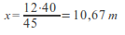
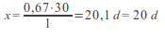
PB1= 1 a, 10 m and 20 d1st
PB2 = The project doesn’t recover 3rd
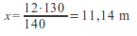
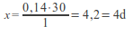
PB3 = 1a, 11 m and 4d 2nd
    - Net Present Value (NPV).- (ex. The discount rate is 2%)
      - Definition.- The Net Present Value of a time series of incoming/outcoming cash flows, is defined as the sum of the current values of the individual cash flows.
      - Reduced.- Each incoming/outgoing flow is reduced to its current value. Then they are added. Therefore, the NPV is the sum of all the terms
      - Selection.- If there is a choice between two alternatives, the greater is the better
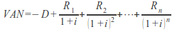
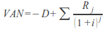
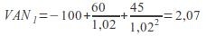 2nd
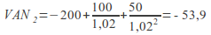 3rd
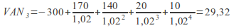 1st
    - The internal rate of return (IRR) .-
      - Definition.- The internal rate of return of an investment is the interest rate at which the costs of the investment match the benefits of the investment. This means that all returns on the investment are inherent in the time value of money and that the investment has a net present value of zero at this interest rate.
      - Acceptable.- An investment is considered acceptable if its internal rate of return is greater than the cost of capital.
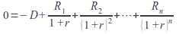
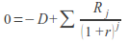
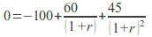
if x = 1 + r
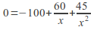
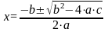
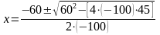
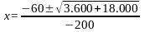
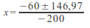
x = 1.0348; so r = 0.0348 = 3.48% 2nd

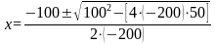
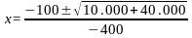
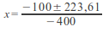
x = 0.8090; so r = -0.191 = -19.1% 3rd

      - I3 (more or less 8% through trial and error) = - 300 + 157.41 + 120.03 + 15.88 + 7.35 = 0.671st
- FINANCING.-
- Definition.- Company financing is an area of finance that deals with the financial decision-making of companies' business and the tools and analysis used to make these decisions.
- TYPES OF FINANCIAL RESOURCES.-
  - Types of financing.-
    - According to its origin.-
      - Internal financing or self-financing.-
        - Definition.- Internal financing is the name for a company using its profits as a source of capital for new investments, instead of: a) distributing them to the owners of the company or other investors and b) obtaining capital elsewhere.
        - They are.- They are amortizations and reserves
      - External financing.-
        - Definition.- External financing consists of new money from outside the company brought in for investment.
        - They are.- They are the capital and liabilities
    - According to who is the owner of the resources.-
      - Own resources.-
        - Definition.- Equity is the asset minus the liability
        - They are.- They are the capital, amortizations and reserves
      - Third-party resources.- They are the liability
  - Internal financing or self-financing.-
    - Inexpensive.- Internal financing is generally thought to be less expensive for the company than external financing because the company doesn’t have to incur transaction costs to obtain it, nor does it have to pay the taxes associated with paying dividends.
    - Determinant.- Many economists debate whether the availability of internal financing is an important determinant of the company's investment or not. A related controversy is whether the fact that internal financing is empirically correlated with investment implies that firms are obligated to credit and therefore depend on internal financing for investment.
    - Financial options.- There are several options for a company to finance itself without external help:
      - Amortization.- Deduction of the value of the asset, reduces the profit before taxes
      - Building reserves.- Eg pension reserves
      - Retained earnings.- The earnings aren’t paid to the owners of the company
      - Change asset.- Selling real estate or other tangible assets owned by the company
    - Advantages of internal financing.-
      - Capital is immediately available
      - No interest payments
      - No control processes with regard to solvency
      - Replacement credit line
      - No influence of third parties
    - Disadvantages of internal financing.-
      - Expensive because internal funding isn’t tax deductible
      - No capital increase
      - Not as flexible as external financing
      - Losses (capital reduction) are not tax deductible
      - Limited in volume (the volume of external financing is also limited but there is more capital available outside - in the markets - than within the company)
    - Types of internal financing or self-financing.-
      - Maintenance self-financing.- They cover the depreciation of assets (amortizations and provisions)
      - Enrichment self-financing.- Increase the company's assets (reserves)
  - Depreciation.- Depreciation is the reduction in the value of an asset used for business purposes during a certain amount of time due to use, over time, wear and tear, technological age or obsolescence, depletion, insufficiency, decay, oxidation, deterioration or other factors
  - Annual amortization fee.- For example, a vehicle that depreciates over 5 years, is purchased at a cost of $17,000, and will have a residual value of $2,000, it will depreciate at $3,000 per year
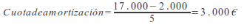
  - Composition of external financing.-
    - Capital.-
    - Passive.-
      - Operating credits.- They’re short-term credits and finance current assets.
      - Financing credits.- They’re long-term credits and finance non-current assets
  - Social capital. The shares.-
    - Nominal value.-
      - Definition.- It’s the value of a share in the title
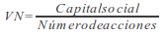
    - Market value.- Share price:
      - Below par.- MV <NV
      - At par.- MV = NV
      - Above par.- MV> NV
    - Theoretical value.-It’s the price of a share according to objective criteria
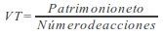
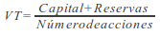
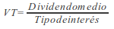
  - Types of shares.-
    - According to the form of representation.-
      - By means of a title
      - By means of an account entry
    - According to the type of contribution.-
      - Monetary contribution
      - Contribution in kind
    - According to its ownership.-
      - Related to the name of a person (nominative)
      - Bearer shares
      - The shares must be registered:
        - As long as they are not fully paid
        - If the shareholders have agreed in the company bylaws that several shareholders should give something to the company
        - If the shareholders have agreed in the company bylaws that the shares can’t be freely sold
        - When determined by law
    - According to the political rights of the shares.-
      - With the right to vote
      - Without voting rights (they have a guaranteed minimum dividend of 5% or another higher according to the company's bylaws, they will also have the ordinary dividend of such shares)
    - According to the privileges that the shares have.-
      - Ordinary
      - Privileged (the law doesn’t admit as a privilege to have an interest rate, to change the number of votes per share and the subscription right)
  - Shareholders' rights.-
    - To receive dividends
    - To participate in the patrimony after liquidation
    - To have a subscription right
    - To vote
    - To receive information
    - To challenge the agreements of the company
  - Types of shares according to the relationship between their issue value and their nominal value.-
    - Shares issued with a premium or above par.-
      - The issue value is greater than the nominal value
      - Premium = Issue Value - Nominal alue
    - Shares issued at par.- The Issue Value is the same as the Nominal Value
    - Shares issued below par (partially or fully released shares) .-
      - The Issue Value is less than the Nominal Value or they’re given free of charge to former shareholders
      - Society pays the difference using its reserves
  - Capital increase and subscription rights.-
    - Definition.- The subscription right is the right of former shareholders to acquire newly issued shares, issued by a company in a correct issue, a usual but not always public offering.
    - Success of the capital increase.- For a capital increase to be successful, the issue value of the new shares must be less than the market value of the old shares, because, otherwise, buying an old share would be more beneficial to buy a new one
    - Compensation to former shareholders.- The subscription right compensates former shareholders for the relative loss of influence within the company and for the distribution of their savings among the owners of the new shares.
    - The purchase of the new shares and the subscription right.- To subscribe new shares we must buy the number of subscription rights according to the agreements of the company (e.g. if a company increases its capital in the proportion 1 x 3, to buy 100 shares we must buy 300 rights, in addition)
    - The sale of subscription rights.- The owner of the old shares who doesn’t want to buy the new ones can sell their subscription rights on the market
    - Value of the subscription right.- The value of the subscription right depends on the market but we can calculate a theoretical value with the following formula:
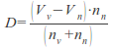
      - Example: Calculate the theoretical value of the subscription right of a 2 x 5 capital increase, if the Market Value of the old shares is €2.5 and the Issue Value of the new ones is €2.2
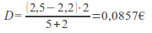
  - Bonds issue.-
    - Definition.- A bond is a debt security that is a part of a loan, in which the authorized issuer owes the holders an amount and, depending on the terms of the bond, is obliged to pay interest (the coupon) and/or to return the principal at a later date, maturity period. A bond is a formal contract to pay back money with interest at fixed intervals.
    - Like a loan.- Therefore, a bond issue is like a loan: the issuer is the one who asks for the money (debtor), the holder is the one who lends money (the creditor), and the coupon is the interest. Bonds issue provide the borrower with external funds to finance long-term investments, or, in the case of government bonds, to finance current spending.
    - Differences between bonds and shares.- Bonds and shares are both titles, but the main difference between the two is that the shareholders have a part of the equity in the company (they are owners), while the bondholders have a part of the credit from a company (they are lenders). Another difference is that bonds usually have a defined period, or maturity, after which the bond is redeemed, while shares can be pending indefinitely.
    - Types of bonds.- The following descriptions aren’t mutually exclusive, and more than one of them may apply to a particular bond.
      - Fixed interest bonds.- They have a coupon that remains constant throughout the life of the bonds.
      - Floating interest bonds.- They have a variable coupon that is linked to a referenced interest rate, such as Euribor. For example, the coupon can be defined as three months Euribor + 0.20%. The coupon rate is recalculated periodically, typically every one to three months.
      - Bonds with zero coupon.- They don’t pay regular interest. They are issued at a substantial discount to par value, so that the interest actually reaches maturity (and is usually taxed as such). The bondholder receives the full amount of the principal on the redemption day.
      - Bonds linked to inflation.- In which the principal amount and interest payments are indexed to inflation. The interest rate is normally lower than for fixed income bonds with a comparable maturity.
      - Asset-backed securities.- These are bonds whose interest and principal payments are backed by underlying cash flows from other assets.
      - Subordinated bonds.- Those that have a lower priority than other obligations of the issuer in the event of liquidation. In bankruptcy, there is a hierarchy of creditors. First the liquidator is paid, then government taxes, etc. The first bondholders queued for payment are those bondholders who are high-ranking bondholders. After they have been paid, the subordinated bondholders are paid. As a consequence, the risk is higher. Consequently, subordinated bonds usually have a lower credit rating than high-ranking ones.
  - The stock market.-
    - Definition.- A stock market is an entity that provides trading facilities for stockbrokers and traders, to trade stocks and other securities. Stock markets also provide facilities for the issuance and redemption of securities in addition to other financial instruments and capital events including the payment of rent and dividends.
    - Primary and secondary markets.- The initial offer of shares and bonds for investors is by definition made in the primary market and the subsequent contracting is made in the secondary market.
    - National Stock Market Commission.- It’s an entity that supervises, inspects and controls the Spanish stock market
    - The role of the stock market.-
      - Raise capital for businesses.- The Stock Market provides companies with the easea to raise capital for expansion through selling shares to the investing public.
      - Mobilize savings for investment.- When people take out their savings and invest in stocks, it leads to a more rational allocation of resources because the funds, which could have been consumed, or put in useless deposits with banks, are mobilized and redirected to promote activities business with benefits for various economic sectors such as agriculture, commerce and industry, resulting in stronger economic growth and high levels of productivity of companies.
      - Facilitate company growth.- Companies view acquisitions as an opportunity to expand product lines, increase distribution channels, avoid volatility, increase their market share, or acquire other necessary business assets. A takeover offer or a merger agreement through the stock market is one of the simplest and most common ways for a company to grow by acquisition or merger.
      - Sharing benefits.- Both casual and professional investors in securities, through dividends and the increase in the price of securities that can result in capital gains, will participate in the patrimony of profitable businesses.
      - Corporate governance.- Having a wide and varied field of owners, companies tend to improve their management standards and efficiency to satisfy the demands of these shareholders and the more rigorous rules for public corporations imposed by public securities markets and government. Consequently, it is presumed that public companies tend to have better management records than privately held companies (those companies where the shares aren’t publicly sold, often owned by the founders of the company and/or their families and their heirs, or otherwise by a small group of investors).
      - Create investment opportunities for small investors.- As opposed to other businesses that require a huge capital outlay, investing in stocks is open to both large and small investors in securities because one person buys the number of shares that they can afford. Therefore the Stock Market provides the opportunity for small investors to own shares in the same companies as large investors.
      - Barometer of the economy.- In the stock market, the price of shares rises and falls depending, in large part, on market forces. Stock prices tend to rise or remain stable when companies and the broader economy show signs of stability and growth. An economic recession, depression, or financial crisis could eventually lead to a stock market crash. Therefore the movement of the prices of the actions and in general of the indexes of values can be an indicator of the general tendency in the economy.
  - The financial system.-
    - Definition of financial system.- The financial system is the system that allows the transfer of money between savers and people who borrow. It’s made up of banks, savings banks, insurance companies, the stock market, etc.
    - Commercial banks (typical operations) .-
      - Passive operations (borrow money).-
        - Current accounts
        - Savings accounts
        - Deposits
      - Active operations (lend money) .-
        - Loans.- It’s short-term or long-term external financing (if it’s for a year or less, it’s short-term and, if not, it’s long-term). The user receives the entire amount agreed from the beginning, forcing him to return this and all interest on certain days established in advance
        - Credit accounts.- It’is short-term external financing. The bank allows the customer to credit for a certain period of time and up to a certain amount, forcing the customer to pay a commission and return the desired amounts within the stipulated limit.
        - Discount of effects.- It’s short-term external financing (normally, 30, 60 or 90 days). The bank anticipates a person the amount of a bill of exchange.
    - Guarantee.-
      - Personal guarantees.- In financing up to five years (we must be responsible with all our personal assets)
      - Real guarantees (mortgage or pledge).- In financing over five years
    - Factoring.- It’s short-term external financing. The factoring is a financial transaction through which a company sells its receivables (eg. invoices) to a third party (called a factor) at an interest rate in exchange for immediate money with which to finance lasting businesses. It's expensive
    - Confirming.- It’s short-term external financing. A financial institution manages the payments of a company to its suppliers. It’s the opposite of factoring (in which the collections of a company from its clients are managed).
    - Leasing.- It is long-term external financing. Leasing is a process by which a company can obtain the use of a certain fixed asset for which it must pay a series of contractual, periodic, and tax deductible payments. In the end, the user has three options: buy the asset, continue with the leasing or return the asset.
    - Renting.- It’s long-term external financing. It’s a long-term rental that includes a series of services and that you don’t have the right to purchase.
    - Deficit in account.- It is short-term external financing. It occurs when the client withdraws more money than is in the account. They are the typical red numbers.
    - Commercial credit.- It’s short-term external financing. It occurs when suppliers allow us not to pay you at the same time you receive the goods but a time later.
    - Spontaneous financing funds.- It’s short-term external financing. It occurs because companies don’t pay the Corporation Tax, Social Security contributions or the remuneration of their workers on a daily basis but once a month or with another cadence; so, in the meantime, they can dispose of that money.
  - Working capital.-
    - Definition.- Working capital is a financial measure that represents the operating liquidity available to a company.
    - Formulas.-
      - Working capital = Current assets - Current liabilities
      - Working capital = Permanent capital - Non-current assets
    - Terms.-
      - Non-current assets or Fixed assets = Buildings, trucks, cars, computers, etc.
      - Current assets = Stock, customers, cash, banks, etc.
      - Permanent capital, Permanent financing or Basic financing) = Equity (Capital, Reserves, etc.) + Non-current liabilities or Long-term debts (Long term loans, etc.)
      - Current liabilities or Short-term debts = Suppliers, etc.
    - Deficit.- If current assets are less than current liabilities, an entity has a working capital deficiency, also called a working capital deficit (current assets can’t pay current liabilities).
    - Value.- Its value depends on the size and sector of the company
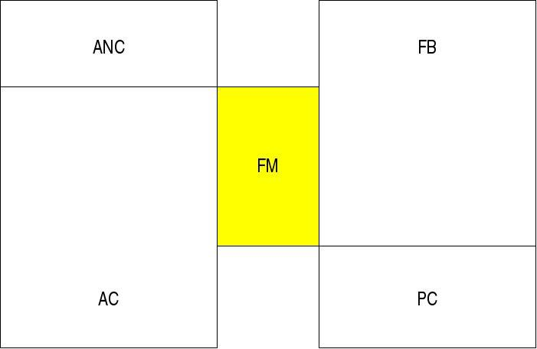
  - The Average Maturity Period.-
    - Definition.- The Average Maturity Period measures how long a company will be in need of cash if it increases its investment in resources to expand sales to customers. It’s, therefore, a measure of the liquidity risk posed by growth. However, shortening the Average Maturity Period creates its own risk: while a company could even reach a negative average maturity period by charging from customers before paying suppliers, a policy of strict charges and lax payments isn’t always sustainable.
    - Calculation.- Average Maturity Period = Period of raw materials or Period of warehouse + Period of products in progress or Period of manufacture + Period of finished products or Period of sales + Period of pending accounts or Period of collections = Pmp + Ppc + Ppt + Pcp
    - Raw materials period or warehouse period.-
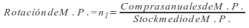
This ratio indicates the number of times we renew the PM stock
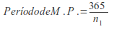
    - Period of products in progress or manufacturing period.-
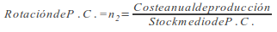
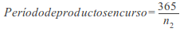
    - Period of finished products or period of sale.-
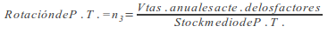
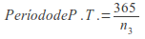
    - Period of pending accounts or collection period.-
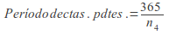
  - Cash-flow (cash flow) .-
    - Definition.- Cash-flow is the movement of cash entering or leaving a business, project or financial product. It’s usually measured over a specified, finite period of time
    - Calculation.-
      - Cash-flow = Accounting profit (net profit before taxes) + Amortizations – Taxes; the oldest is the best
        - 1st example.- If: BAIT (gross profit) = 10; Amortizations = 3; Interest = 2 and Tax = 35%
        - Accounting profit = BAIT – Interest; Cash-flow = 10 - 2 + 3 - 0.35 x (10 - 2) = 8.2
        - 2nd example.- If: Income = 15; Expenses = 7; Amortizations = 2 and Taxes = 35%
        - Cash-flow = 15 - 7 + 3 - 0.35 (15 - 7) = 8.2
- THE FINANCIAL COST.-
  - Debt ratio.-
    - Definition.- The debt ratio is a financial ratio that indicates the relative proportion of the shareholders' equity and the debt used to finance the assets of a company. Closely related to leverage, the ratio is also known as Risk, Orientation or Leverage. The two components are often taken from the company's balance sheet, but the ratio can also be calculated using market values for both, if the company's debts and equity are publicly traded, or using a combination of book value for the debt and market value to equity financially.
  - Financial structure.-
    - Definition of financial structure.- The financial structure refers to the way in which a company finances its assets through some combination of equity, debt or hybrid securities.
    - Optimal financial structure.- According to the traditional thesis, the optimal financial structure is the relationship between liabilities and equity that minimizes the cost of funds and maximizes the value of the company
    - Modigliani and Miller.- According to Modigliani and Miller, an optimal financial structure doesn’t exist
    - Josep Faus.- According to Josep Faus, it’s difficult to determine an optimal financial structure for any company and he recommends looking at the average financial structure of the companies in the sector
    - Leverage effect.- If the benefits obtained thanks to the funds used are greater than the interest that we must pay for them, then we obtain financial profitability

PART 4.- PATRIMONY STRUCTURE AND ANALYSIS OF THE FINANCIAL STATEMENTS

- PATRIMONY CONCEPT.-
  - Concept.- It’s the set of goods, rights and obligations that belong to a natural or legal person
  - Composition.-
    - Liabilities.- Third-party resources (funds)
    - Equity.- Own resources (funds)
    - Assets.- Goods and rights in which the previous resources or funds are invested
  - Fundamental identity of the Patrimony.-
    - Assets = Liabilities + Equity, or
    - Assets = Required liabilities + Own liabilities
- PATRIMONY ORGANIZATION.-
  - Balance sheet structure of a normal company.-
    - The structure of a company will depend on the sector to which it belongs
    - ENDESA will have a non-current asset greater than 20% since it needs more Fixed Assets
    - A legal office will have a non-current asset of less than 20% since it needs less Fixed Assets
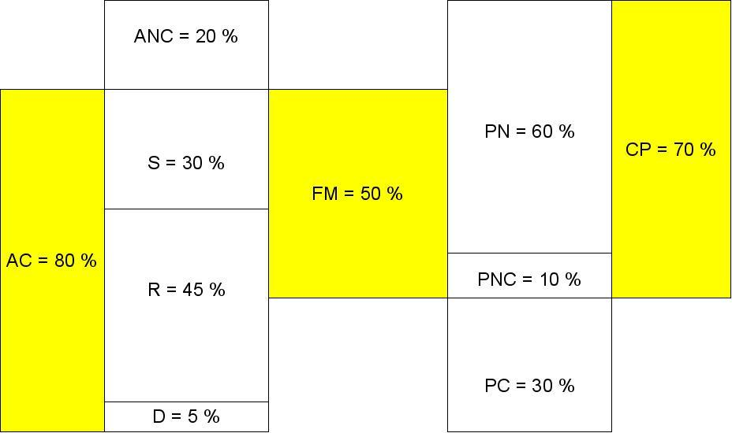
- ELEMENTS AND PATRIMONY MASSES.-
  - Definition of patrimony element.- It’s each one of the goods, rights or obligations that make up the patrimony of a natural or legal person
  - Account definition.- It’s the name that has a patrimony element according to the General Accounting Plan
  - Some Asset accounts.- Land and natural assets, Constructions, Machinery, Furniture, Transport elements, Merchandise, Raw materials, Fuels, Spare parts, Finished products, Clients, Clients, trade receivables, Debtors, Cash, euros, Banks and institutions of cto.c/c, view euros, banks and institutions of cto.c/savings, view euros
  - Some Equity accounts.- Capital, Legal reserve, Voluntary reserve
  - Some Liability accounts.- Long-term debts with credit institutions, Long-term debts with suppliers of fixed assets, Suppliers, Suppliers of commercial bills payable, Short-term debts with credit entities, Short-term suppliers of fixed assets
  - Definition of patrimony mass.- It’s a group of elements that have the same economic-financial meaning
  - Classification of the patrimonial masses.-
    - In three.- Assets, Liabilities and Equity
    - According to its liquidity and enforceability.-
      - Non-current assets.- Groups the different elements that remain in the company's patrimony for more than one year
        - Intangible assets.-
          - Rights with economic valuation that belong to the patrimony of the company for more than one year
          - Administrative concessions, industrial property (patents, etc.), computer applications (programs), goodwill (figure in which the clientele and market position of a company are valued when it is acquired by another), etc.
        - Inmobilized material.-
          - Assets goods, tangible, that remain for more than one year in the assets of the company
          - Land and natural assets, buildings, machinery, etc.
      - Current assets.- It consists of those assets that the company uses in its activity and that, in the course of it, are usually converted into money
        - Inventories or stock.- Finished products, merchandise, etc.
        - Debtors or realizable.- Clients, clients, commercial bills receivable, debtors, etc.
        - Treasury or available.- Cash, Banks, etc.
      - Equity.- Mainly Capital and reserves
      - Non-current liabilities.- Mainly debts of more than one year
      - Current liabilities.- Mainly debts of one year or less. For example, Suppliers (which is an account that collects the commercial credits that they grant us) another example could be Suppliers, commercial bills to pay
    - Definition of liquidity.- It’s the ease of transforming a patrimonial element into money
    - Definition of enforceability.- It’s the facility that third parties have to request a payment from the economic unit
    - Example of classification of assets.- Group elements of a company, according to its liquidity and enforceability, with the following accounts: Cash, euros (2); Capital (9); Land and natural assets (5); Suppliers (2); Merchandises (1); Reserves (6); Constructions (4); Clients (3); Banks c/a (3); Long-term debt (1) (Solution on the next page)
- THE BALANCE SHEET.-
  - Inventory, balances and social balance.-
    - Definition of inventory.- It’s a detailed list of all the elements (assets, rights and obligations) duly valued, which belong to a company at a given time
    - Definition of balance sheet.- It has the same definition as the inventory, although, in the balance sheet, the valuation of the different elements comes from the accounting and in the inventory it comes from a count and valuation outside of it
    - The social balance.- Measures the impact of each company in the social environment where it’s inserted. In France and Germany it has a certain importance, in Spain it hardly has it
  - Balance sheet example.-
ASSETS |  | EQUITY AND LIABILITIES
Non-current assets (NCA) | 9 | Net Equity (NE) | 15
Land and natural assets | 5 | Social capital | 9
Buildings | 4 | Reserves | 6
Current assets (CA) | 9 | Non-current liabilities (NCL) | 1
Stock | 1 | Long-term debts | 1
Merchandise | 1 | Current liabilities (CL) | 2
Realizable | 3 | Providers | 2
Customers | 3
Available | 5
Cash, euros | 2
Banks c/a | 3
Total | 18 | Total | 18
  - The balance sheet.-
    - The balance sheet will include.- With due separation, the assets, liabilities and equity of the company
    - Current assets will comprise.-
      - Assets linked to the normal operating cycle that the company expects to sell, consume or carry out during the same
      - Those assets, different from those mentioned in the previous paragraph, whose maturity, disposal or realization is expected to occur in the short term.
      - Financial assets classified as held for trading, except financial derivatives whose settlement term is greater than one year
      - Cash and equivalent liquid assets
    - Non-current assets will understand. - Other assets
    - Current liabilities will include.-
      - Obligations linked to the normal operating cycle
      - Obligations whose expiration or termination is expected to occur in the short term
      - Financial liabilities classified as held for trading, except financial derivatives whose settlement term is greater than one year
    - Non-current liabilities will include.- The other elements of the liability
    - Net amount.- A financial asset and a financial liability may be presented on the balance sheet for their net amount provided that certain conditions are met.
    - Valuation corrections for damage and accumulated amortizations.- They will reduce the asset item in which the corresponding equity element appears
    - Research.- In the event that the company has capitalized research expenses, a specific item "Research" will be created within the Intangible Fixed Assets
    - Real estate investments.- The land or buildings that the company uses to obtain rental income or possesses in order to obtain capital gains through its disposal, outside the ordinary course of its operations, will be included in Real estate investments.
BALANCE SHEET
ASSETS |  | EQUITY AND LIABILITIES
A) NON-CURRENT ASSETS |  | A) EQUITY
I. Intangible assets |  | A-1) Own funds
II. Inmobilized material |  | A-2) Adjustments for change in value
III. Investment Property |  | A-3) Subsidy, donation, and legacies received
IV. Long term investments in businesses of the group and associated |  | B) NON-CURRENT LIABILITIES
V. Long term financial investments |  | I. Long term provisions
VI. Deferred tax assets |  | II. Long term debts
B) CURRENT ASSETS |  | III. Long term debts with businesses fo the group and associated
I. Non-currents assets held for sale |  | IV. Deferred tax liabilities
II. Stocks |  | V. Long term accruals
III. Trade debtors and other accounts to collect |  | C) CURRENT LIABILITIES
IV. Short term investments in businesses of the group and associated |  | I. Liabilities related to non-current assets held for sale
V. Short term financial investments |  | II. Short term provisions
VI. Short term Accruals |  | III. Short term debts
VII. Cash and other equivalent liquid assets |  | IV. Short term debts with businesses of the group and associated
 |  | V. Commercial creditors and other accounts to pay
 |  | VI. Short term accruals
TOTAL ASSETS |  | TOTAL EQUITY AND LIABILITIES
- THE ACCOUNTING BOOKS.-
  - Accounting objective.- To inform about the economic and patrimonial situation of the company. To do this, study the patrimony and its variations
  - Accounting duties of the company.-
    - Keep an orderly accounting
    - Keep a book of Inventories and Annual Accounts and a Journal
    - The mercantile companies will also keep a minute book
    - Fill out the books in the Mercantile Registry
    - Keep the books, correspondence, documentation and supporting documents concerning your business duly ordered for six years
    - Formulate the annual accounts at the end of the year
    - Value assets in accordance with generally accepted accounting principles
  - The reliable picture.-
    - The annual accounts must be written clearly, so that the information provided is understandable and useful for users when making their economic decisions, and must show a reliable picture of the assets, financial situation and results of the company, in accordance with legal provisions.
    - In those exceptional cases in which such compliance is incompatible with the reliable picture that the annual accounts must provide, such application will be considered inadmissible.
  - The Journal.- In it, the operations related to the activity of the company are recorded day by day
    - It is one of the compulsory books
    - Example.- The entry that we would make in the Journal if we buy goods on credit for 2,000 euros would be the following:
2000 | Merchandise purchases | to | Suppliers | 2000
  - The General ledger.- The movements of each account on the different dates are recorded in it.
    - It is optional
  - General ledger example.-
Banks and credit institutions
3 | 3
1 | 1

  - The inventory book and annual accounts.-
    - Trial balances or sums and balances.- Its purpose is to verify that the items recorded in the Journal have been correctly transferred to the Geneal ledger
      - It is necessary to do one every quarter
      - Example of balance of sums and balances.-
ELEMENTS | Amounts Debt | Sums credit | Balances Debt | Credit balances
Social capital |  | 9 |  | 9
Reserves |  | 6 |  | 6
Long term debts |  | 1 |  | 1
Lands and natural goods | 5 |  | 5
Buildings | 4 |  | 4
Merchandise | 1 |  | 1
Suppliers |  | 4 |  | 4
Customers | 8 |  | 8
Cash, euros | 2 | 1 | 1
Banks c.a. | 4 | 3 | 1
Purchases of merchandise | 2 |  | 2
Leases and royalties | 1 |  | 1
Supplies | 3 |  | 3
Merchandise sales |  | 5 |  | 5
Another financial income |  | 1 |  | 1
TOTALS | 30 | 30 | 26 | 26
    - The annual accounts.-
      - Documents that make up the annual accounts.-
        - The balance sheet, the profit and loss account, the statement of changes in equity, the cash flow statement and the memory. These documents form a unit and must be written in accordance with the existing regulations.
        - When a balance sheet, statement of changes in equity and an abbreviated report can be formulated, the statement of cash flows will not be compulsory.
      - Formulation of the annual accounts
        - Periodicity.- Every twelve months
        - Who formulates them and within what period? .- They’re formulated by the employer or managers, who will answer for their veracity, within a maximum period of three months, counting from the close of the financial year.
- TAXATION.-
  - Taxes. Elements and definitions.-
    - Taxable event.- It’s the reason for which the tax obligation appears
    - Tax base.- It’s the quantification of the taxable event
    - Net base.- It’s the taxable base less deductions, reductions and compensations
    - Tax rate.- It’s the percentage that is applied to the Net base to calculate the tax quota
    - Tax quota.- It’s the result of applying the tax rate to the Net base
    - Tax debt.- It’s the tax rate plus surcharges and less bonuses
  - The Value Added Tax.- The VAT is an indirect tax on consumption, that is, financed by the final consumer. An indirect tax is the tax that isn’t received by the treasury directly from the taxpayer. VAT must be collected by companies at the time of any sale of products (transfer of goods and services). Companies have the right to be reimbursed the VAT that they have paid to other companies on purchases made in exchange for invoices (tax credit), subtracting it from the amount of VAT charged to their customers (tax debit), having to deliver the difference to the treasury. End consumers are obliged to pay VAT without the right to reimbursement,
  - The Corporation Tax.-
    - Definition.- It’s a periodic, proportionate, direct and personal tribute. Taxes the income of companies and other legal entities
    - Scope of application.- It’s applied throughout the Spanish territory, with the exception of the Basque Country and Navarra (by means of a concert)
    - Taxable event.- It’s the obtaining of income by certain taxpayers (legal persons and other entities without personality).
OTHER ANNUAL ACCOUNTS
- THE PROFIT AND LOSS ACCOUNT. THE RESULTS OF THE COMPANY.-
  - It collects the result of the year, consisting of the income and expenses thereof, except when their direct allocation to equity is appropriate.
  - Income and expenses will be classified according to their nature
ABBREVIATED PROFIT AND LOSS ACCOUNT
ACCOUNTS | (DEBIT)/CREDIT
1. Net amount of turnover
2. Variation in finished and in process of manufactures product inventories.
3. Work made by the company for its assets
4. Supplies
5. Other operating income
6. Staff expenses
7. Other operating expenses
8. Amortization of Fixed Assets
9. Allocation of subsidies for non-financial fixed assets and others
10. Excess provisions
11. Damage and result from Fixed Assets sales
A) OPERATING RESULT
12. Financial income
13. Financial expenses
14. Variation in fair value of financial instruments
B) FINANCIAL RESULT
C) RESULT BEFORE TAX
17. Income tax
D) RESULT OF THE YEAR
- THE MEMORY.-
  - Mission.- The Memory completes, expands and comments on the information contained in the other documents that make up the annual accounts.
  - Content of the summarized Memory.-
    - Activity of the company.- Corporate purpose of the company and the activity or activities to which it is dedicated
    - Basis of presentation of the annual accounts.-
      - Reliable picture.-
        - The company must make an explicit statement that the annual accounts reflect the reliable picture of the assets, the financial situation and the results of the company, as well as in the case of preparing the statement of cash flows, the veracity of the flows incorporated
        - Exceptional reasons why, to show a reliable picture legal provisions haven’t been applied in accounting matters with an indication of the legal provision not applied and qualitative and quantitative influence for each fiscal year
      - Non-mandatory accounting principles applied.-
      - Critical aspects of valuation and estimation of uncertainty.-
      - Information comparison.-
        - Exceptional reasons that justify the modification of the structure of the balance sheet, the profit and loss account, the statement of changes in equity and, if prepared, the statement of cash flows of the previous year
        - Explanation of the causes that prevent the comparison of the annual accounts for the year with those of the previous one
        - Explanation of the adaptation of the amounts of the previous year to facilitate the comparison and, if not, the exceptional reasons that have made it impractical to restate the comparative figures
      - Items collected in various items.-
      - Changes in accounting criteria.-
      - Error correction.-
      - Results application.-
      - Registration and valuation standards.-
      - Property, plant and equipment, intangible assets and real estate investments.-
        - Analysis of the movement during the fiscal year of each of these headings of the balance sheet and of their corresponding accumulated amortizations and valuation corrections for damage accumulated
        - In any case, all the information about the transfers or reclassifications between the different categories of financial assets that have occurred in the year must be provided.
        - Finance leases and other operations of a similar nature on non-current assets
      - Financial assets.- The book value of each of the categories of financial assets will be disclosed.
      - Financial liabilities.- The book value of each of the categories of financial liabilities will be disclosed.
        - Information about:
          - The amount of the debts that mature in each of the five years following the end of the year and the rest until their last maturity
          - The amount of the debts with real guarantee, indicating their form and nature
          - The amount available in the discount lines, as well as the credit policies granted to the company with their respective limits, specifying the part used
        - In relation to loans pending payment at the end of the year, the following will be reported:
          - Details of any non-payment of principal or interest that has occurred during the year
          - The book value at the year-end date of those loans in which there had been a default due to non-payment, and
          - If the non-payment has been remedied or the loan conditions have been renegotiated, before the date of preparation of the annual accounts
      - Equity.-
        - The number and nominal value of each class of shares shall be indicated, distinguishing by classes, as well as the rights granted to them and the restrictions they may have. Also, if applicable, the pending disbursements will be indicated for each class, as well as the due date.
        - Specific circumstances that restrict the availability of reserves
        - Number, nominal value and average acquisition price of the shares held by the company or by a third party acting on its behalf
      - Fiscal situation.-
      - Incomes and expenses.-
        - Purchases and changes in inventories will be broken down
        - Social charges will be broken down
        - The item "Other operating expenses" will be broken down.
        - The amount of the sale of goods and provision of services produced by barter
        - The results originated outside the normal activity of the company
      - Subsidies, donations and bequests.-
      - Operations with related parties.-
      - Other information.-
        - The average number of people employed in the course of the year, expressed by categories
        - The nature and business purpose of the agreements of the company that don’t appear in the balance sheet and on which information hasn’t been incorporated in another note of the report, as well as their possible financial impact, provided that this information is significant and of help in determining the financial position of the company
- STATEMENT OF CHANGES IN EQUITY.- It has two parts:
  - Statements of recognized incomes and expenses.- It includes the changes in equity derived from:
    - The result of the financial year of the profit and loss account
    - Income and expenses that must be charged directly to the company's equity
    - The transfers made to the profit and loss account
SUMMARIZED STATEMENT OF RECOGNIZED INCOMES AND EXPENSES
ACCOUNTS | (Debit)/Credit
A) Profit and loss account result
Incomes and expenses charged directly to equity
I. By valuation of financial instruments
II. For cash flow hedges
III. Subsidies, donations and heritages received
IV. For actuarial gains and losses and other adjustments
V. Tax effect
B) Total incomes and expenses charged directly to equity
Transfers to the profit and loss account
VI. By valuation of financial instruments
VII. For cash flow hedges
VIII. Subsidies, donations and heritages received
IX. Tax effect
C) Total transfers to the profit and loss account
TOTAL RECOGNIZED INCOME AND EXPENSES
  - Total statement of changes in equity.- Reports all changes in equity derived from:
    - The total balance of recognized income and expenses
    - Variations originated in the equity due to operations with the partners or owners of the company when they act as such
    - The remaining variations that occur in equity
    - Adjustments to equity due to changes in accounting criteria and corrections of errors will also be reported (see PGC)
- STATEMENT OF CASH FLOWS.- Reports on the origin and use of monetary assets representing cash and other equivalent liquid assets. Cash and other equivalent liquid assets are understood as cash, banks current account and saving account and fixed-term deposits of no more than three months. Occasional overdrafts may also be included as a component of cash when they form an integral part of the company's cash management.
SUMMARY STATEMENT OF CASH FLOWS (NOT ABBREVIATED) | 200X
A) CASH FLOWS FROM OPERATING ACTIVITIES
1. Profit for the year before tax
2. Result adjustments
4. Other cash flows from operating activities
5. Cash flows from operating activities (+/- 1 +/- 2 +/- 3 +/- 4)
B) CASH FLOWS FROM INVESTMENT ACTIVITIES
6. Payments for investments (-)
7. Collections for divestments (+)
8. Cash flows from investing activities (7-6)
C) CASH FLOWS FROM FINANCING ACTIVITIES
9. Collections and payments for equity instruments
10. Collections and payments for financial liability instruments
11. Payments for dividends and remuneration of other equity instruments
12. Cash flows from financing activities (+/- 9 +/- 10-11)
D) Effect of changes in exchange rates
E) NET INCREASE/DECREASE IN CASH OR EQUIV. (+/- 5 +/- 8 +/- 12 +/- D)
Cash or equivalent at the begining of the exercise
Cash or equivalents at the end of the year

- INTERPRETATION OF THE ANNUAL ACCOUNTS.- When interpreting the annual accounts, we compare the situation of the company in different years. The auditor must indicate whether the alterations to the information are justified or not and if they aren’t, issue a report with qualifications.
- ASSET ANALYSIS. FINANCIAL ANALYSIS.-
  - Equity analysis.-
    - Valuation of the company as a whole.-
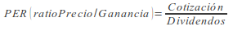
    - Valuation of the patrimonial masses.-
      - Assessment criteria.-
        - Historical cost or cost.- Of an asset is its acquisition price or production cost. Of a liability is the value that corresponds to the consideration received or that will be received in the future in exchange for incurring the debt
        - Fair value.- It will be the price quoted in an active market. Transaction costs that may be incurred in its sale will not be deducted
        - Net realizable value.- An asset is the amount that the company can obtain from its sale by deducting its costs. From raw materials and products in progress, the estimated costs to complete their production, construction or manufacture
        - Present value.- It’s the value of the disbursements and reimbursements updated
        - Value in use.- It’s the current value of the expected future cash flows, through their use or their sale, taking into account their current status.
        - Selling costs.- These are those that the company wouldn’t have incurred had it not made the decision to sell, excluding financial expenses and taxes on profits. Legal expenses necessary to transfer ownership of the asset and sales commissions are included.
        - Amortized cost of a financial instrument.- It’s the amount which was initially rated a financial asset or financial liability, minus repayments of principal that have occurred, more or less, as appropriate, the portion allocated to the profit and lesss and minus any impairment reduction
        - Transaction costs attributable to a financial asset or liability.- Those that wouldn’t have been incurred if the company hadn’t carried out the transaction
        - Book value.- It’s the net amount for which an element is recorded on the balance sheet once, in the case of assets, its accumulated depreciation and any accumulated value correction for damage that has been recorded has been deducted.
        - Residual value.- It’s the amount that the company estimates that it could obtain at the current moment from its sale
      - Inmobilized material.-
        - Initial valuation.- Assets included in property, plant and equipment will be valued at their cost, whether this is the acquisition price or the production cost. Acquisition price.- Includes all expenses until its start-up. Production cost.- It’s the industrial cost (Raw material + Direct labor + General manufacturing expenses directly attributable to the product + General manufacturing expenses not directly attributable to the product). Swaps: Of a commercial nature = fair value + money given in exchange, Of a non-commercial nature = book value + money given in exchange (with the limit of the fair value of the good). Non-cash capital contributions = Fair value
        - Subsequent valutation.- For their acquisition price or production cost minus accumulated depreciation and, where appropriate, the cumulative amount of damage losses recognized at the end of the year ( there will be a loss for damage of an element of the property, plant and equipment when its book value exceeds its recoverable amount, understood as the higher amount between its fair value less costs to sell and its value in use)
        - Land.- Normally they have an unlimited life and, therefore, aren’t amortized
      - Intangible assets.-
        - Initial valuation.- Same as Inmobilized material
        - Subsequent valuation.- If it has an indefinite useful life, it won’t be amortized, although its eventual deterioration must be analyzed. The useful life of an intangible asset will be reviewed each year to determine if there are facts or circumstances that allow continuing to maintain an indefinite useful life for that asset.
        - Goodwill.- Will not be amortized
        - Amortization and valuation correction.- Intangible assets must be subject to both
      - Credits (for commercial or non-commercial operations) .-
        - Initial valuation.- Fair value = Transaction price + transaction costs. However, credits for commercial operations with a maturity of not more than one year and that don’t have a contractual interest rate may be valued at their nominal value when the effect of not updating the cash flows isn’t significant.
        - Subsequent valuation.- At its amortized cost
        - Damage of value.- At the end of the fiscal year, valuation corrections will be made
      - Debits (for commercial or non-commercial operations) .-
        - Initial valuation.- Fair value = Transaction price + transaction costs. However, debits for commercial operations with maturity not exceeding one year and that don’t have a contractual interest rate may be valued at their nominal value.
        - Subsequent valuation.- At its amortized cost
      - Stocks.-
        - Initial valuation.- For its acquisition price or production cost. The acquisition price includes the amount invoiced by the seller after deducting any discount, price reduction or other similar items as well as the interest incorporated into the face of the debits, and all additional expenses that occur until the goods are located for sale. The production cost is the industrial cost
        - Value assignment methods.- Generally the WAP, also accepting the FIFO
        - Operation.- (In all cases we sell 700 units at 300 euros each)
        - Weighted average price.- Exits are made at the average price of existing units using the following formula:
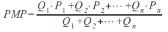
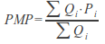

Date | Purch.  Q | Purch.  P | Purch.  PxQ | Sales  Q | Sales  P | Sales  PxQ | Stocks  Q | Stocks  P | Stocks  PxQ
10/01 | 500 | 100 | 50,000 |  |  |  | 500 | 100 | 50,000
01/15 | 600 | 110 | 66,000 |  |  |  | 1,100 | 105.45 | 116,000
01/20 | 400 | 115 | 46,000 |  |  |  | 1,500 | 108 | 162,000
01/30 |  |  |  | 700 | 108 | 75,600 | 800 | 108 | 86,400

        - FIFO (first in, first out).-
          - First entry, first exit. Exits are made at the price of the first entries
          - If there is strong inflation, the FIFO overvalues the stock (€ 90,000)
Date | Purch.  Q | Purch.  P | Purch.  PxQ | Sales  Q | Sales  P | Sales  PxQ | Stocks  Q | Stocks  P | Stocks  PxQ
10/01 | 500 | 100 | 50,000 |  |  |  | 500 | 100 | 50,000
01/15 | 600 | 110 | 66,000 |  |  |  | 500  600 | 100  110 | 50,000  66,000
01/20 | 400 | 115 | 46,000 |  |  |  | 500  600  400 | 100  110  115 | 50,000  66,000  46,000
01/30 |  |  |  | 500  200 | 100  110 | 50,000  22,000 | 400  400 | 110  115 | 44,000  46,000

        - LIFO (last in, firs out) .-
          - Last entry, first exit. Exits are made at the price of the last entries
          - If there is strong inflation, the LIFO undervalues the stock (€83,000)

Date | Purch.  Q | Purch.  P | Purch.  PxQ | Sales  Q | Sales  P | Sales  PxQ | Stocks  Q | Stocks  P | Stocks  PxQ
10/01 | 500 | 100 | 50,000 |  |  |  | 500 | 100 | 50,000
01/15 | 600 | 110 | 66,000 |  |  |  | 500  600 | 100  110 | 50,000  66,000
01/20 | 400 | 115 | 46,000 |  |  |  | 500  600  400 | 100  110  115 | 50,000  66,000  46,000
01/30 |  |  |  | 400  300 | 115  110 | 46,000  33,000 | 500  300 | 100  110 | 50,000  33,000

        - Subsequent valuation.- When the net realizable value of inventories is less than their purchase price or cost of production, appropriate valuation adjustments recognized as an expense shall be made in the profit and loss
      - Changes in accounting criteria, accounting errors and estimates.-
        - They will respect the principle of uniformity and will be applied retroactively.
        - The income or expense corresponding to previous years derived from said application will motivate a change in a reserve item
      - Events after the close of the financial year.- Those that reveal conditions that didn’t exist at the close of the financial year won’t entail an adjustment in the annual accounts. However, if they aren’t of importance, they will be included in the memory.
    - Patrimony situations and balances.-
      - Position 1.-NCA + CA = E; L = 0
        - There are no debts
        - Maximum financial stability
      - Position 2.- NCA + CA = L; E = 0
        - There are no own funds, everything is debts
      - Position 3.- NCA + CA = E + L; being CA>CL and resulting in positive working capital
        - It’s the normal balance
      - Position 4.- NCA + CA = E + L; being CA<CL and resulting in negative working capital
        - The company would be in what was previously called suspension of payments (if the situation is temporary) or bankrupt (if it is permanent)
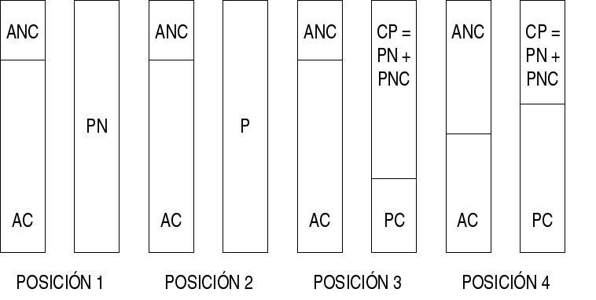
    - Dynamic analysis of patrimony.-
      - With this analysis it is intended to study the patrimonial variations over time
      - The basic document for the elaboration of this analysis is the state of origin and application of funds
      - Example.-
ASSETS |  |  |  | EQUITY AND LIABILITIES
Periods> | N-1 | N | Variation |  | N-1 | N | Variation
NCA  I  R  A | 100  20  25  65 | 110  18  20  62 | + 10  -2  -5  -3 | E  NCL  CL | 60  75  75 | 60  50  100 | 0  -25  +25
TOTALS | 210 | 210 | 0 | TOTALS | 210 | 210 | 0

      - The increase in non-current assets has been due to decreases in inventories, realizable and available
      - The decrease in non-current liabilities was due to an increase in current liabilities
  - Financial analysis of patrimony. Main economic-financial ratios.- Data from the balance sheet on page 86, taking into account the structure of the Balance Sheet of a normal company on the same page to calculate the ideal values
    - Treasury ratios.-
      - Immediate availability (immediate treasury) .-
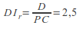
Normal ≥ 0.17; Ideal = 0.17
      - Treasury (acid-test) .-
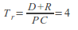
Normal ≥ 1.67; Ideal = 1.67. If it were lower than this value, it would mean that a suspension of payments could occur since the company would have to temporarily disregard its payments
    - Solvency and financial autonomy ratios.-
      - Cash-flow = Accounting profit + amortizations – taxes; the larger the better
        - Example 1.- If: Profit before interest and taxes (BAIT) = 10; Amortization = 3; Interest = 2 and Tax over profit = 35%
        - Accounting profit = BAIT – Interest; Cash-flow = 10 - 2 + 3 - 0.35 x (10 - 2) = 8.2
        - Example 2.- If: Income = 15; Expenses = 7; amortization = 3 and Tax over profit = 35%
        - Cash-flow = 15 - 7 + 3 - 0.35 x (15 - 7) = 8.2
      - Liquidity or current solvency.-
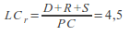
Normal ≥ 2.67; Ideal = 2.67
      - Total liquidity.-
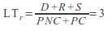
Normal between 1 and 2; Ideal = 2
      - Total guarantee, structural guarantee or bankruptcy distance.-
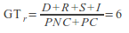
Normal ≥ 1, if it were less, it would be bankrupt; Ideal = 2.5
      - Financial autonomy.-
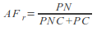
Normal ≥ 1.5; Ideal = 1.5. The higher it is, the less dependence it will have on external financing
    - Debt ratios.-
      - Total indebtedness.-
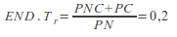
Normal ≤ 0.67; Ideal = 0.67
      - Long term indebtedness.-
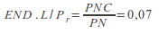
Normal ≤ 0.17; Ideal = 0.17
      - Short term debt.-
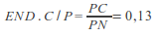
Normal ≤ 0.5; Ideal = 0.5
    - Capital availability and immobilization ratios.-
      - Immobilization.-
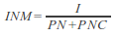
Normal ≤ 1; Ideal = 0.29
      - Availability of own funds.-
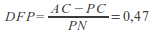
Normal ≥ 0.83; Ideal = 0.83. The higher the value of the ratio, the more availability of own resources will be
      - Basic financing ratio.-
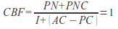
Normal = 1; Ideal = 1. This ratio should be very close to unity, which will indicate that the financing is correct
- ECONOMIC ANALYSIS.-
  - Example.- Taking into account that the earnings before interest and taxes (BAIT) have amounted to 4, the interest on the debts to 1, the value of the production of the period has been 2 and the total sales of the period have amounted to 5. The income tax amounts to 2
  - Economic profitability.-
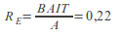
the higher the ratio the better
  - Other ratios associated with the analysis of economic profitability.-
    - Production cost.-
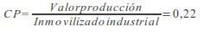
the higher the better
    - Profitability of immobilizations.-
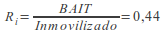
the higher the better
    - Profitability on sales.-
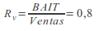
the higher the better
  - Financial profit.-
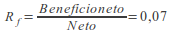
the higher the better
Net profit = BAIT - Int - Imp

PART 5.- THE COMPANY AND ITS ENVIRONMENT
- THE COMPANY AND THE ENTREPRENEUR.-
  - Company concept.- A company is a set of human, material, financial and technical factors organized and driven by management, which tries to achieve objectives in accordance with the purpose previously assigned
  - Theories about the company.-
    - Neoclassical or marginalist theory.-
      - It takes place from the middle of the 19th to the beginning of the 20th centuries
      - Its main authors were Jevons, Menger, Walras and Marshall
      - According to this theory, the mission of companies is simply to produce
      - This theory doesn’t explain the real operation of companies since they aren’t only concerned with producing but with other things, such as achieving social needs
    - Social theory.-
      - The objective of companies shouldn’t only be to maximize profits but also have to cover social needs
      - The way in which the company achieves social needs is reflected in the Social Balance
      - Areas of the Social Balance.-
        - Internal.- It collects labor relations and the management style of the company
        - External.- It collects the costs and social benefits that occur as a result of its activity, specifically with its suppliers, clients, the environment and with the community where it carries out its activities.
    - Theory of transaction costs.-
      - Its main authors were Coase and Williamson
      - According to this theory, a company will grow (through vertical integration) until it is more expensive for it to carry out this phase of the production process itself than to entrust it to other companies (for example: SEAT will manufacture its car tires if i’is cheaper than buying them from MICHELIN )
  - The company as a system.-
    - Definition of system.- A system is a set of elements interrelated with each other and with the global system, which has objectives
    - Characteristics of the company as a system.-
      - The company is an open system.- Since it’s interrelated with its environment
      - Synergy occurs in the company.- Synergy consists of a team achieving more than the sum of what all its components would have achieved individually.
      - The company is a global system.- Any influence on one of its elements has repercussions on the others and on the system as a whole
      - The company is a self-regulating system - The company controls itself
    - Subsystems that can be distinguished in the company.-
      - The system of physical flows.- Through which raw materials, products in progress, finished products, etc. circulate.
      - The financing system.- It transforms savings into investment. It’s made up of the financing and investment subsystems
      - The management system.- It acts on the other two and which, in turn, is functionally formed by the planning, organization, management and control subsystems.
  - Company and entrepreneur.-
    - Theories on the concept of entrepreneur.-
      - Capitalist entrepreneur or business owner.- Early 19th century
      - Innovative entrepreneur (Shumpeter) .- He’s capable of launching a new business opportunity taking advantage of an invention or an unexploited idea (it isn’t who invents it but who exploits it)
      - Entrepreneur who assumes risks (Knigth).- He has expenses that he will recover or not
      - Galbraith's technostructure.- In the new large companies, those who actually hold business power aren’t the partners of the company but the senior managers who control it
    - Concept of employer according to the Workers' Statute.-
      - An entrepreneur is any natural or legal person or community of goodss that receives, on a voluntary basis, the provision of paid services from those who work for others and within the scope of the organization.
- OBJECTIVES AND FUNCTIONS OF THE COMPANY.-
  - Company functions.-
    - Directive.- Decides how the objectives of the company will be achieved through planning, organization, coordination and control
    - Technical or production.- Performs activities for the manufacture of goods or the provision of services
    - Research and development.- Improvement of methods and programming and launch of work plans
    - Financial.- Gets the necessary financial resources
    - Human resources management.- Selects, hires, trains, motivates and promotes staff
    - Purchases.- Acquisitions
    - Commercial.- Sales
    - Administrative.- Control the documentation
  - Objectives.-
    - Economic or profitability.- Maximum profit
    - Growth.-
      - Intensive.- In a new area (SEAT enters Russia); a very similar product (SMART)
      - Integrated.- In another phase of the same production process
        - Backwards.- CALVO - Fishermen
        - Forwards.- CALVO - HIPERCOR
        - Horizontal.- CONTINENT AND PRYCA IN CARREFOUR
      - Diversified.- Another activity (BMW produced aircraft engines and began to manufacture cars)
    - Social.- Cover social needs (ecology, security, help to the poors, etc.)
  - Definition of competitive advantage.- It’s the value that a company is capable of creating for its buyers. It’s the disbursement that buyers are willing to make for the products or services that a company provides them (eg home delivery of purchases from a supermarket)
- ELEMENTS THAT COMPOSE THE COMPANY.-
  - Technical capital.- It’s the set of items of a material or immaterial nature, not intended for sale, that a company has to produce goods and services. It refers to Tangible Fixed Assets (Land and natural assets, Constructions, Transport elements, Machinery, etc.) and Intangible Fixed Assets (Industrial Property, Computer applications, Goodwill, Administrative concessions, etc.). All this will be seen in detail in topic 10 (Assets and balance sheet)
  - Human element.- Refers to workers. We will see all this expanded in topic 6 on Human Resources Management
  - Tangible items. - It refers to tangible fixed assets but also to the part of current assets that we can touch, that is to say, goods (merchandise, raw materials, finished products, semi-finished products, containers, packaging, etc.). We will see all this in more detail in topic 10 (Assets and balance sheet)
  - Intangible elements.- Refers to intangible fixed assets but also to the part of current assets that we cannot touch, that is, to rights and obligations (clients; clients, commercial bills receivable, debtors; debtors, commercial bills receivable; short-term debt; long-term debts; suppliers; suppliers, commercial bills to be paid; etc.). We will see all this better in topic 10 (Assets and balance sheet).
- FUNCTIONS THAT DEVELOP WITHIN THE GENERAL ECONOMY.- Companies are the economic agents that make decisions about the production and distribution of goods and services
- INTERNAL AND EXTERNAL GROWTH STRATEGIES.-
  - Internal growth.- It’s the increase in size that is produced by the new investments of the company. This growth is in the medium or long term since investments take time to be made
  - External growth.- It’s the one that occurs as a result of the mergers or takeovers of the company
  - Merger and acquisition strategies.-
    - Equal merger.- Two companies of a similar size come together, creating a new company. Both lose their legal personality (Continente and Pryca gave rise to Carrefour)
    - Merger by absorption.- A larger company acquires a smaller one that loses its legal personality (El Corte Inglés absorbed Galerías Preciados)
    - Merger by spin-off.- A company disappears, distributing its assets in several companies. The old one loses its legal status (at first, Rover SUVs were owned by Ford, the Mini was owned by BMW and the rest of the cars were owned by a company that has been incorporated with the former workers)
    - Participation of capital without merger.- A company acquires shares of another to dominate it. It doesn’t lose its legal personality (Renault has acquired a significant package of Nissan shares to dominate it)
    - Holding.- A parent company acquires all or a significant part of the capital of other companies to dominate them. It doesn’t lose its legal personality. In pure holding companies, the parent company has as its social objective to dominate the others (example: RUMASA), in mixed holding companies it also has its own objective (example: La Caixa)
  - Cooperation between companies.-
    - Trust.- Vertical concentration (different phases of the production process) through capital participation of some companies over others
    - Cartel.- Horizontal concentration to agree prices, distribute the market, etc. (they are illegal in the European Union)
    - Temporary unions of companies.- To carry out a specific work or service. They don’t have their own legal personality. Unlimited and joint liability (Example: The union of the Utrera road with the SE30 has been built by a joint venture made up of two companies)
    - Economic Interest Groups (AIE) .- Several companies that share a common good. For example: several driving schools create an AIE to repair their cars. It has its own legal personality. Joint and unlimited liability
  - Association with another company.-
    - Commercial concession.- The concession company undertakes to market the products supplied by the transferor firm, in exchange for a commission.
    - The franchise.- There are two types:
      - One in which the franchisee manufactures or markets products and services under the name and brand of the franchisor, from which they can receive assistance, equipment and some control in their management
      - Another, the same as the previous one, but the franchisor's products aren’t manufactured or marketed, but any other

- CLASSIFICATION ACCORDING TO THEIR ECONOMIC ACTIVITY.-
  - Commercial.- They buy and sell products without transformation
  - Industrial.- Transform products
  - Of services.- They provide services
- ACCORDING TO THE ECONOMIC SECTOR TO WHICH THEY BELONG.-
  - Primary sector companies.- Extractive activities (agriculture, livestock, fishing, mining, etc.)
  - Secondary sector companies.- Industry and construction
  - Tertiary sector companies.- Services
- ACCORDING TO ITS DIMENSION.-
  - By number of workers.-
    - Microenterprise.- From one to five workers
    - Small business.- From six to fifty workers
    - Medium-size company.- From fifty-one to five hundred workers
    - Large company.- More than five hundred workers
  - Other criteria to measure the size of companies.-
    - Equity
    - Assets
    - Production volume
    - The sales figure
    - The use of production factors (in addition to the number of employees)
    - The profits
    - One multi-criteria value (using several at the same time)
  - The business location.-
    - Objectives to be achieved with a good business location.-
      - Minimize production and/or distribution costs
      - Optimize market access to ensure regular supplies
      - Reduce storage costs, and
      - Increase business volume
    - The industrial location.-
      - Factors that influence the industrial location.-
        - The availability of land and its price
        - Access to raw materials and other supplies (for example, refineries are often built by the sea)
        - The availability of labor
        - The existence of auxiliary industry (repairs, transportation, parts, etc.)
      - Land uses and urban location.-
        - Industrial companies are usually located on the outskirts of cities for the following reasons:
          - Good communication and transportation systems
          - Close to markets
          - Existence of skilled and abundant workforce
          - Municipal services with the capacity to serve companies
        - Industries must be located on land for industrial use and need a municipal license to do so
      - Commercial and services location.-
        - The radius of action.-
          - It’s the market area to which the influence of an establishment or point of sale reaches a certain good or service
          - It’s different depending on the type of product
          - Those that are acquired daily (bread, newspapers, etc.) have a small radius of action, those that are acquired occasionally usually have a greater radius of action (shoes, clothes, etc.)
          - It also depends on the price; the most expensive have a greater radius of action than the cheapest
          - The business radius can be expanded by offering any extra service to the customer (financing, transportation, free assembly and installation, etc.)
        - The break-even point.- It’s the minimum dimension that a market must have for a store or point of sale to be viable. If the market is below the break-even point, a business installed in it won’t be able to survive.
        - Measures that favor access to a point of sale.-
          - Site visibility
          - Ease of communications
          - Situation on traffic sidewalks
          - Location in areas with complementary activities
          - Well decorated premises with a comfortable stay and transit
        - Location of the points of sale according to the type of activity to which they’re dedicated.-
          - Activities of a primary nature (bakeries, bars, grocery stores, etc.) are usually found spread over residential areas
          - Activities with a somewhat larger radius of action would be concentrated in a part of the same residential areas
          - In large cities, business activities are concentrated in business areas
          - Industrial activities would be concentrated in the periphery of cities
          - Hypermarkets are also located on the outskirts of cities
  - The dimension of the companies.-
    - Dimension and productive capacity.-
      - Production capacity.-
        - It is the value of production achievable when all resources are in full employment
        - The production capacity is closely related to the size of the company, since the larger the size is, the larger the production is
      - Idle capacity.-
        - It’s the difference between the production capacity and the production actually obtained
      - The degree of underutilization.-
        - It is the percentage of the production capacity that isn’t used
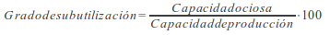
    - The microeconomic theory and the business dimension.-
      - The most convenient dimension according to the general doctrine.-
        - It’s one in which average total costs are minimized
        - This point is called the optimum of exploitation.
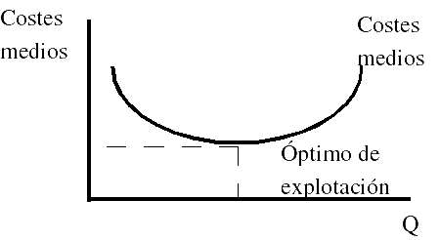
      - The most convenient dimension according to the "law of proportional effect" .-
        - This thesis maintains that there is no optimal dimension that guarantees minimum costs to companies, since the long-term average cost curve doesn’t have a minimum, but is parallel to the abscissa axis.
        - According to this law, companies don’t grow to seek greater profitability but to:
          - Seek power and the effort to monopolize the market
          - The desire of professional managers to increase their influence
          - Diversification of activities
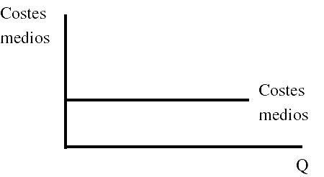
- ACCORDING TO THE OWNERSHIP OF THE CAPITAL.-
  - Public owned companies.- The capital is in the hands of the State
  - Private owned companies.- The capital is in the hands of people
  - Mixed.- Part of the capital is in private hands and part is of the State
- ACCORDING TO THE GEOGRAPHICAL SCOPE.-
  - Local.-
  - Nationals.-
  - International.-
- CLASSIFICATION ACCORDING TO ITS LEGAL FORM.-
  - The individual entrepreneur.-
    - Definition.- He’s the natural person who, having the necessary legal capacity, regularly exercises a business activity independently
    - Concepts to take into account.-
      - Emancipated.- A minor who has been married or who, being over sixteen years of age, his parents or guardians have allowed him to live outside the family home and without financially depending on them
      - Legal capacity.- Abstract possibility of being the holder of rights and obligations. The natural or physical person acquires it at birth; the legal person with its constitution or creation in accordance with legal regulations
      - Capacity to act.- Possibility of exercising by yourself the rights and obligations of which you’re the owner. The natural or physical person acquires it with the age of majority or with emancipation; the legal person, as well as the legal capacity
    - The capacity to contract of the individual entrepreneur.-
      - Adults and emancipated minors can personally hire people or sign contracts
      - Non-emancipated minors can be entrepreneurs and hire people or sign contracts, through a legal representative
    - Features.-
      - Unlimited liability
      - Registration in the Mercantile Registry isn’t mandatory but is convenient (since later it won’t be able to sign any document)
      - Minimum capital: Doesn’t have
  - Individual Limited Liability Companies (EIRL) .-
    - Concept.- They’re legal persons, formed exclusively by a natural person, with their own assets and different from that of the owner, who carry out activities of a purely commercial nature (not second category activities). The EIRL are subject to the rules of the Commercial Code, whatever their purpose, being able to carry out all kinds of civil and commercial operations, except those reserved by law for Public Limited Companies.
    - Particularities.-
      - Identification.- The owner must give, at least, his name and surname, and may also have a fantasy name, added to that of the economic activities or business. This name must be closed with the phrase "Individual Limited Liability Company", or use the abbreviation "EIRL".
      - Constitution.- By public deed, the extract of which is registered in the Commercial Registry and published in the Official Journal.
      - Duration.- It can be determined or indefinite.
      - Type of person.- The generation of an EIRL allows to give life to a legal person, always of a commercial nature.
      - Liability.- The owner of the individual company responds with his patrimony and only with the contributions made or that he has agreed to incorporate. For its part, the company responds for its obligations generated in the exercise of its activity with all its assets
      - Special publicity.- Formality and special publicity must be given to the contracts that the individual company has with its owner, when the latter acts within their personal patrimony
      - Administration.- Corresponds to its owner; however, it can give general or special powers to a manager or agent.
      - End.- To put an end to the company, the will of the businessman, the end of its duration or the death of the owner stand out.
      - Inheritance.- In the event of the death of the businessman, his heirs can continue with the company.
      - Transformation.- The individual company can be transformed into a limited company and a limited company can become an individual company. In the latter case, the rights of the disappearing society must be brought together in the hands of a single natural person.
      - Applicable regime.- It’s the Legal Statute of Limited Liability Companies.
  - Communities of goods.-
    - Definition.- It consists of a group of individual entrepreneurs who share some good
    - Features.- Unlimited liability
  - Civil societies.-
    - Definition.-
      - They are those that, without being public limited companies nor limited liabilities companies, carry out an activity that can’t be industrial or commercial (eg a law firm)
      - If the constitutive pact remains hidden, it functions as a community of goods
    - Features.-
      - Minimum of partners: two
      - Unlimited liability (the company responds first and then, subsidiarily, the partners)
  - The partnership society.-
    - Particularities.-
      - It’s a personalistic society
      - The name of the company (trade name) must appear that of the partners.
      - There may be capitalist partners (they contribute work and capital) or industrial partners (they only contribute work)
      - The capital is divided into shares
      - The shares are listed in the corporate deed and their transmission requires the unanimous consent of all partners.
      - The partners, unless expressly agreed, will receive as contributed, except the industrial partner who will receive the same as the capitalist partner with the lowest contribution
      - The administration will correspond, unless expressly agreed, to all the partners, who should agree
      - The partners can’t compete against the company itself
    - Features.-
      - Public deed: Yes
      - Registration in the Mercantile Registry: Yes
      - Minimum of partners: two
      - Minimum capital: No
      - Responsibility: Unlimited (first the company responds and then, in a subsidiary way, the partners)
  - The simple limited partnership.-
    - Particularities.-
      - It is a personalistic and capitalist society
      - They have two types of partners: collective and limited partners
      - Limited partners can’t participate in the administration of the company
      - The name of the limited partners shouldn’t appear in that of the partnership
    - Features.-
      - Public deed: Yes
      - Registration in the Mercantile Registry: Yes
      - Minimum of partners: two
      - Minimum capital: No
      - Liability: Limited for limited partners and unlimited for collective partners
  - The limited partnership by shares.-
    - Particularities.-
      - It’s a personalistic and capitalist society
      - The administration must be to the collective partners
      - Form of incorporation the same as the Public Limited Companies
    - Features.-
      - Public deed: Yes
      - Registration in the Mercantile Registry: Yes
      - Minimum of partners: Two
      - Minimum capital: €60,101.21
      - Liability: Limited for comanditary partners and unlimited for collective partners
  - Limited responsibility society.-
    - Particularities.-
      - They can only be born by simultaneous foundation (the partners undertake to acquire all the capital)
      - Fully paid up capital from the start
      - Capital divided into shares
      - In order to sell these shares, the authorization of the General Meeting of partners is necessary.
    - Features.-
      - Public deed: Yes
      - Registration in the Mercantile Registry: Yes
      - Minimum of partners: One
      - Minimum capital: €3,000
      - Liability: Limited
    - Organs.-
      - The General Meeting of partners.- Supreme decision-making body. It can be called by the administrators in accordance with the Law (within a period of three months from 12/31 or when requested by partners who have at least 5% capital), the statutes or, failing that, by Judge. It can also be called by unanimous decision of the entire capital at the Universal Meeting
      - Administrators.- Management and representation body
        - One-person body.-
        - Multi-person body.-
          - Supportive administrators.- They act independently
          - Joint administrators.- They make decisions unanimously
          - Board of Directors.- Decisions are taken by majority
      - The auditors.- Review the annual accounts and the management report
  - New limited liability company.-
    - Legal regime.- It’s a specialty of the limited liability company.
    - Social denomination.-
      - The name of the new company company will consist of the two surnames and the name of one of the founding partners followed by an alphanumeric code that allows the identification of the company in a unique and unequivocal way.
      - The name of the company must necessarily include the indication "New Limited Company" or its abbreviation "SLNE".
    - Subjective requirements.-
      - Only natural persons may be members of the new company.
      - At the time of incorporation, the partners may not exceed the number of five.
    - One-personality.- Those who already hold the condition of sole partners of another new company may not constitute or acquire the condition of sole partner of a new company.
    - Social capital.-
      - The capital stock of the new company may not be less than three thousand twelve euros nor more than one hundred twenty thousand two hundred two euros.
      - The capital stock can only be paid up through monetary contributions.
    - Subjective requirements in the transfer of shares.- As a consequence of the transfer of shares, the number of five partners may be exceeded.
    - Structure of the administration body.- When the administration is attributed to a multi-person body, in no case will it adopt the form and the operating regime of a board of directors.
    - Increase in share capital above the maximum limit.- If the partners agree to increase the share capital above the maximum limit established by law, they must also establish whether they opt for the transformation of the new company into any other social type or whether they continue its operations in the form of a limited liability company.
    - Dissolution.- The new company will be dissolved for the causes established in the law for the limited liability company and, in addition, as a consequence of losses that reduce the equity to an amount less than half of the share capital for at least six months, unless equity is restored within that period.
    - Conversion into a limited liability company- The new company may continue its operations in the form of a limited liability company, for which it will require the agreement of the general meeting and adaptation of the bylaws of the new company to the provisions for the constitution of a limited liability company.
  - The public limited company.-
    - Particularities.-
      - It can be born by simultaneous foundation (the partners undertake to acquire all the capital) or successive (the promoters look for subscribers of the shares)
      - The capital must be fully subscribed from the beginning and paid up at least 25 percent
      - The capital pending disbursement is called a passive dividend
      - The capital stock is divided into shares that can be registered or bearer
      - They can be represented by titles or by means of annotations in account (they are registered through accounting transfers)
      - Listed shares must be represented by annotations in account
    - Features.-
      - Public deed: Yes
      - Registration in the Mercantile Registry: Yes
      - Minimum of partners: One (sole proprietorship)
      - Minimum capital: €60,000
      - Liability: Limited
    - Bodies.- Same as in Limited Liability Companies
  - European public limited company (SE) .-
    - Prohibition of identity of denominations.- A European public limited company that is going to have its domicile in Spain whose name is identical to that of another pre-existing Spanish company may not be registered in the Mercantile Registry.
    - Registered office.- The European public limited company must establish its registered office Spain when its central administration is within Spanish territory.
    - Administration systems.-
      - Monistic system.
      - Dual system
    - Bodies of the dual system.- In the event that a dual administration system is chosen, there will be a management and a control Council.
    - Management powers.- The management and representation of the company correspond to the management.
    - Ways to organize the management.-
      - The management may be entrusted, in accordance with the statutes, to a single director, to several directors who act jointly or jointly or to a board of directors.
      - When the management is entrusted jointly to more than two people, these will constitute the board of directors.
    - Composition of the Board of directors.- It consist of a minimum of three members and a maximum of seven.
    - Functioning of the control board.- In principle, the provisions of the law for the operation of the board of directors of companies shall apply to the control board.
    - Appointment and revocation of the members of the control board.- In principle, the members of the control board will be appointed and revoked by the general meeting.
    - Representation before the members of the control board.- The representation of the company before the members of the management corresponds to the control board.
    - Call for the general meeting in the dual system.-
      - In the dual system of administration, the competence to call the general meeting corresponds to the management. The management must convene the general meeting when requested by shareholders who are holders of at least five percent of the capital stock.
      - If the meetings were not convened within the deadlines established by the Regulation (CE) or the statutes, they may be called by the control council or, at the request of any partner, by the commercial judge of the registered office in accordance with the provisions for the general meetings in this law.
      - The Control Board may call the general shareholders' meeting when it deems it convenient for the corporate interest.
  - Listed public limited companies.-
    - Concept.- Listed companies are public limited companies whose shares are admitted to trading on an official secondary stock market.
    - Representation of the shares of listed companies.- Necessarily by means of annotations in account
    - Prohibition of abbreviated accounts.- Companies whose securities are admitted to trading on a regulated market of any Member State of the European Union, may not formulate an abbreviated balance sheet and statement of changes in net worth or an abbreviated profit and loss account.
  - Labor companies.-
    - Particularities.-
      - Labor Limited Liability Companies and Labor Public Limited Companies, the same as Limited Liability Companies and Public Limited Companies but, at least, the majority of their capital must belong to the workers linked to the company by an indefinite employment contract.
      - No partner may own shares (which must be nominative and must be represented in securities) or participations that represent more than a third of the capital, except public entities, which can hold up to 49%
      - The minimum number of partners is three, although the new law allows two temporarily
      - The shares reserved for workers are called labor class, those reserved for non-workers are called general class
      - These companies can hire workers who don’t acquire the status of partners but the number of hours worked by them may not exceed 15% of the annual work dedicated to the company by the working partners; this percentage rises to 25% in companies with less than 25 workers
      - The "labor class" shares can be acquired: 1st by workers with an indefinite contract who aren’t partners , 2nd by worker partners, 3rd by non-working partners and 4th by the rest of the workers without an indefinite contract
      - It is mandatory to allocate 10% of the profit obtained to a special reserve fund
    - Features.-
      - Public deed: Yes
      - Registration in the Mercantile Registry and in the Registry of Labor Public Limited Companies
  - Cooperative societies.-
    - Constitution.- The promoters will hold a constituent assembly of which the corresponding minutes will be drawn up, which will be signed by all of them. They must register in the Registry of Andalusian Cooperatives.
    - Minimum number of members.- The first degree members must be made up of at least three common members, and the second or subsequent degree members must be made up of at least two immediately previous degree cooperatives.
    - Incorporation and cancellation of partners.- It’s voluntary and free.
    - Share capital.- It’s set in the bylaws and is variable, depending on the number of members that enter or leave the cooperative.
    - Limit of the contribution.- In first-degree cooperatives, no member may have a contribution greater than one third of the share capital.
    - Disbursement.- The capital must be fully disbursed at the time of incorporation.
    - Company name.- If it is Andalusian, it must include, at the end, Sociedad Cooperativa Andaluza; if the liability is unlimited, it must include, at the end, Sociedad Cooperativa Andaluza Ilimitada.
    - Funds.- Cooperatives must allocate 30% of surpluses to the Mandatory Reserve Fund and the Education and Promotion Fund.
    - Sections.- The bylaws may provide for the constitution and operation of sections, with management autonomy and separate assets, within the cooperative society, in order to develop specific or complementary economic activities to its corporate purpose. The meeting of the members of the section constitutes its Board of members, which may choose from among them a collegiate management body, the Section Council, or a single member, the Section Management. The sections won’t have independent legal personality, without prejudice to the patrimonial independence foreseen for those belonging to cooperative housing societies.
    - Possible partners.- Any natural or legal person, public or private, as well as civil societies and communities of property and rights, may be a member of a cooperative society.
    - Classes of partners.- Common (if the cooperative activity is fully carried out), work (if it only provides work), inactive (eg due to retirement) and collaborator (if it doesn’t carry out the main cooperative activity, but contributes to the achievement of the object cooperative or participates in one or more of its accessories)
    - Investors.- They make the contributions to the capital that are determined and don’t develop the cooperative activity -the former partners can become investors.
    - Responsibility.- The responsibility of the partners for the corporate debts will be limited to the amount of the contributions subscribed to the capital stock, whether or not they are paid.
    - Audit.- Cooperatives must submit the annual accounts and other necessary documents to an external audit in various cases.
    - Votes.- In first degree cooperative societies, each common member will have the right to one vote, without prejudice to the option provided for service cooperative societies. In cooperative societies of the second or subsequent degree, the statutes may establish the plural voting system depending on the degree of participation of each partner in the cooperative activity, or the number of partners of each legal person integrated in the structure. associative.
  - Social bodies.- The preceptive are the General Assembly and the board; and the optional ones are the Technical Committee and the Intervention
  - The general assembly.-
    - It’s the supreme organ of expression of the will. General assemblies can be ordinary (which is convened within the six months following the close of the financial year to analyze corporate management) and extraordinary (the rest).
    - The ordinary one must be convened 1st by the administrative body (within six months following the close of each financial year), 2nd by the Technical Committee, 3rd by the Secretary of the Governing Council and 4th by the competent judicial body (at the request of any partner)
    - The extraordinary will be called 1st by the administrative body on its own initiative, and likewise, when requested by a number of partners representing, at least, 10% of the partners in cooperatives of more than 1,000, 15% in those of more than 500 and 20% in the rest, 2nd by the Technical Committee, 3rd by the Secretary of the Governing Council and 4th by the competent judicial body (at the request of any member requesting the Extraordinary General Assembly)
    - The General Assembly will have the character of universal when, without a formal call, all the partners of the cooperative society are present or represented, and accept, unanimously, its celebration.
  - Administration body.-
    - The administrative body of cooperative societies will be the Governing Council (in cooperatives with more than ten common partners) or the Sole Administration and the Joint Administration (in those with ten or less, if determined by their statutes)
    - The Governing Council is the governing, management and representation body. In any case, the Presidency, the Vice-presidency and the Secretariat will form part of it. One third of the directors may be non-members if, thanks to their knowledge and experience, they contribute to the functioning of the body. The duration of the mandate of the Governing Council may not be less than three years or more than six; although its members can be re-elected
    - If there is no Governing Council, the faculties of the Presidency and the Secretariat will correspond to the Sole Administration or, indistinctly, to each of the persons holding the joint representation, respectively.
  - The Technical Committee.- The Technical Committee will be made up of at least three members without prejudice to the fact that the statutes provide for the existence of an external advisor. In any case, the number of members must be odd. The term of office will vary between two and six years. The duration of their mandate may not coincide with that corresponding to the administrative body. The members of the Technical Committee will be assigned all or some of the following functions: monitoring and control, resolution of claims, resolution of appeals, guarantee and information.
  - Intervention.- In cooperative societies with more than ten members, the statutes may provide for the existence of an Intervention body. Its members, always in odd numbers, will be elected for a term of office ranging from two to six years. The duration of the mandate of this body may not coincide with that of the administrative body. The following functions correspond to the auditors: review the annual accounts and other documents that are determined by regulation and report to the General Assembly on the matters or questions that it submits to them.
  - Direction.- The statutes may provide for the establishment of a Direction made up of one or more persons. The powers of the members of the Direction will be extended to matters concerning the ordinary business activity or traffic of the cooperative society. Its members will attend the sessions of the administrative body with voice and without vote.
  - Classes of cooperatives.-
    - Work.- The partners carry out any economic activity of production of goods or services for third parties.
    - Business impulse.- Canalyze the entrepreneurial initiative of their partners.
    - Of social interest.- Dependency, protection of childhood and youth, etc. They may or may not be for profit
    - Of transport.-
    - Of consumption.-
    - Household.-
    - Credit.- They finance their partners (with very good conditions) and third parties (with normal conditions)
    - Insurance.-
    - Services.- They allow their partners, who are usually professionals who carry out their activity on their own account, the use or enjoyment of industrial operations, services.
    - Agrarian.-
    - Maritime, river or lake.
    - Mixed.- They develop several different activities
    - Public services.- They provide some useful and necessary service for the community, such as water and sanitation, taxi, telephones, garbage collection, etc.
    - Other formulas Cooperatives.- Cooperatives social integration, public services, community land use, etc.
    - Cooperative group.- It can be proper (one cooperative commands the others) or improper (all have the same power)
    - Other forms of bonding.- Cooperative societies of any kind or type may establish companies, associations, groups, consortia and unions of companies, of any kind, among themselves or with other people and formalize agreements or agreements for the better fulfillment of their social purpose and for the defense of their interests without, in any case, distorting their cooperative nature.
- SMALL AND MEDIUM-SIZED COMPANIES.-
  - Small and medium-sized enterprises and their social role.-
    - Importance of SMEs.- In the industry they account for 97% of the entire sector
    - Characteristics of an SME.-
      - It participates in a minority way in the market and, therefore, doesn’t influence its operation
      - Ownership of capital belongs to one person or a small group of partners
      - The SME lacks control of other companies so its decisions are usually autonomous
    - Advantages of SMEs.-
      - Flexibility and ability to overcome situations of temporary change (by not suffering from too important structural loads, they can even change activity in a short time)
      - They can act as auxiliaries to large companies in industrial production (manufacture of components, parts, etc.) or in the distribution of services
      - Due to their proximity and direct relationship with the client, they enjoy a privileged position in local markets
      - They can experience with greater probability of success the direct participation of the worker in the decisions and plans of the company
      - They adapt more easily to the client
      - Absence of conflicts for the control of the company since they’re usually personalistic
      - A low failure rate can be achieved, given the greater knowledge they have of the clientele
    - Disadvantages of SMEs.-
      - They can’t enjoy economies of scale, so they’re less competitive
      - They have more difficulty obtaining financing than large companies
      - They don’t have the technical capacity of the big
      - They can’t impose conditions on their clients as they have little force
      - They can be easily acquired by large companies
    - Present and future of SMEs: the European market.-
      - What should SMEs do to adapt to the European market? .-
        - Deal with activities of low-scale economies
        - Promote direct customer service
        - Improve product quality
        - Adapt, with agility, to changes in demand
        - Expand your markets to other countries of the European Union
      - Where can SMEs find out about community issues? .- At the euro windows
- TRANSNATIONALITY: MULTINATIONAL COMPANIES.-
  - Definition and origin.-
    - They’re companies formed by a parent company that controls a series of subsidiaries that operate in different countries of the world
    - They’re born in the traffic of the colonial companies with the respective headquarters of the metropolis
  - Characteristics and current situation.-
    - The main characteristic of transnational companies is their centralized management
    - The current economy favors this type of company due to:
      - The creation of free trade areas
      - The reduction of tariff barriers and restrictions in world trade
      - The unprecedented development of communications, where new computer technologies (information highways) stand out
      - Large financial institutions invest anywhere in the world
  - Multinational development factors: location and transnationality (why do companies decide to become multinational?) .-
    - The conquest of new markets.-
    - Overcoming protectionist barriers - Producing directly in the countries (example, NISSAN in the EU)
    - Take advantage of competitive advantages.- Cheaper labor, less demanding environmental legislation, proximity of raw materials
    - Technology or product transfers in decline.- Take advantage of outdated technology in less developed countries (example, RENAULT in Turkey)
  - Organizational structure of transnational companies.-
    - Structures.-
      - Subsidiaries that produce (to avoid protectionism)
      - Subsidiaries that don’t produce, only market (when there’s no protectionism)
    - Forms of organic connection between the different centers.-
      - Branch opening (the most centralized)
      - Creation of subsidiary companies whose capital is wholly owned by the parent company
      - Creation of subsidiary companies whose capital belongs, in part to the multinational, and in part to a State company that is the recipient of the investments (joint ventures)
    - Ways to organize control centers.-
      - A single control center
      - Various regional centers
- LOCATION AND SECTORIZATION OF THE ANDALUSIAN ECONOMY.-
  - Primary Sector.- Despite being the one that contributes the least to the economy, it continues to have a great relative importance with the rest of the productive sectors. Importance that becomes greater if we compare it with the primary sector of other western economies, where it has been reduced to a minimum. The primary sector produces 8.26% of the total and employs 8.19% of the active population. It’s undoubtedly a not very competitive sector since other economies with a much smaller employed population produce much more.They have spread the cultivation under plastic in greenhouses, highlighting the horticultural crops of western Almeria. The Riofrío fish farm in Granada, which exports up to 40 percent of its caviar production, competing in international markets with Russian and Iranian caviar
  - Secondary sector.-
    - Industry.- It should be noted that the development of industries in the 19th century linked to mining extraction (Garrucha and Carboneras, Riotinto, El Pedroso, Peñarroya and Linares-La Carolina) failed. At the beginning of the 21st century, although there is greater intersectoral integration between mining extraction and industrial transformation, this is still insufficient and incomplete. The scarcity of fuel resources of fossil origin, or their low calorific value, causes a strong dependence on imported oil in the Andalusian energy sector, although Andalusia has great potential for the development of renewable energies, especially solar and wind energy. There’re other less important industries such as automotive, aeronautics, etc.

Construction.- At the beginning of 2008, the international financial crisis worsened significantly, with banking entities showing a worrying decline in profits, coupled with sharp declines in the stock market. In this context, the construction industry begins to show evident symptoms of crisis: a strong decrease in the number of sales, a decrease in the price of housing, a sustained increase in non-performing loans, or an increase in unemployment in the sector (thus, for example, the closure of half of the real estate agencies in Spain). In February, the Spanish economy shows obvious symptoms of an economic crisis, registering the largest increase in unemployment in the last 25 years and a sharp drop in hiring.

Tertiary sector.- The tertiary sector or services, both in terms of production and employment, in recent decades has experienced a very significant growth in its participation in the economy. It has gone from being a minority sector to being a vast majority in most Western economies. This process has been called tertiarization of the economy and has manifested itself, in a peculiar way, in the Andalusian economy. In this way, in 1975 the service sector produced 51.1% of the Andalusian GVA and employed 40.8%, while in 2007, it produced 67.9% of the GVA and 66.42% of the jobs. However, this growth in the tertiary sector occurred earlier than in other developed economies and was independent of the industrial sector.

- ANALYSIS OF THE DIFFERENT FACTORS THAT MAKE UP THE GENERAL AND SPECIFIC ENVIRONMENT OF THE COMPANY.
  - Economic system of Spain.- Spain is a market economy delimited by social needs (so it’s not a pure market economy but a mixed economy)
  - The company within the framework of the European Union.-
    - European Union companies are free to trade and establish themselves in any country of the Union
    - Any action that restricts or distorts competition is prohibited, with the exception of those that contribute to improving the production or distribution of products or promoting technical or economic progress and reserves to users an equitable share of the resulting benefit (example: milk quotas, olive trees, etc.)
    - Member States are prohibited from granting subsidies or aid that favor certain companies, except in the case of aid to economically depressed regions, granted in situations of natural disasters, aimed at promoting culture or the conservation of the historical-artistic heritage, etc.
  - Other factors of the general and specific environment where companies operate.-
    - Socio-cultural factors.- Culture and religious or other beliefs make companies decide to settle in one country or another (eg Ford Morocco-Spain)
    - Technological factors.- Technology is the way of combining production factors to obtain a certain good or service. In countries where there is a lot of labor, a labor-intensive technology will be used, in countries with a high level of development and high wages, another technology based on mechanization will be used.
    - Sociological factors: pressure groups.- They’re fundamentally trade union organizations and business associations
  - The close or specific environment of the company.- It’s made up of competitors, pressure groups, clients and suppliers
- INTERNATIONALIZATION. THE GLOBAL COMPETITION.-
  - Explanatory factors for the existence of international trade.-
    - Countries specialize in the products in which they obtain greater comparative advantages (that is, they produce them at a lower cost than the rest) by:
      - Weather conditions
      - Mineral wealth
      - Technology, and
      - Available amount of labor, capital and arable land
  - Competitiveness in the international framework.- We’re witnessing a process of internationalization and globalization of the economy (General Agreement on Tariffs and Trade GATT, free trade areas, common markets, ...)
  - Strategies.-
    - Cost leadership.- Achieve the lowest costs
    - Differentiation.- Make your product or service stand out from others through quality improvement, special guarantees, brands, etc.
    - Segmentation.- Offer each group of buyers the product they want
- INFORMATION TECHNOLOGY.-
  - Definition of computer science.- It’s the science that studies the rational treatment of information, from the moment it’s generated until it’s effective for its use, using human, logical, electronic, mechanical and telematic resources.
  - The computer, its components and functions.-
    - Generations and characteristics.- So far there have been four generations
      - The speed, amount of memory and storage capacity has been increasing
      - The size and cost have been reduced
      - Programming has become easier and easier
      - In the first two generations, monoprogramming was given to later move on to multiprogramming
      - Valves were used in the first, transistors in the second, integrated circuits in the third, and microprocessors in the fourth.
      - In the first two generations the data was stored on magnetic tapes, in the third on hard drives and floppy disks and in the fourth on hard drives, CDs and DVDs
      - In the first generation the media didn’t have direct access but later they already had it
      - In the first generation there was no remote communication and then there was
      - In the first two generations there were no networks then yes
    - The computer.-
      - Composition.- The central processing unit (CPU) and the input and/or output peripherals
        - The Central Process Unit.-
          - Performs control, logic and calculation processes
          - It is composed of: the arithmetic-logical unit, the control unit and the main memory
          - The arithmetic unit is responsible for performing arithmetic operations
          - The control unit manages the entire process and controls the arithmetic logic unit and main memory
        - Peripheral elements.- Mainly they’re the keyboard, the screen, the floppy disk drives, the CD drive, the DVD drive, etc.
  - Computer supports.-
    - It’s where the information is collected
    - They can be tapes, floppy disks, CDs, DVDs, etc.
  - Hardware and software.-
    - The hardware is the physical components (the Central Process Unit, the screen, the keyboard, the mouse, etc.)
    - The software is the programs (Windows, Word, Access, Excel, etc.)
  - Computer operating systems and applications.-
    - Operating systems are the programs that manage the computer
    - The most important are: MS-DOS and Windows
    - Computer applications are programs that help make jobs easier
    - The most popular computer applications are: the Word word processor, the Access database, the Excel spreadsheet, the PowerPoint presentation program, etc.
  - Internet.- The main uses of the Internet are:
    - The electronic mail (e-mail)
    - Participation in forums and bulletin boards (news)
    - File transfer (FTP)
    - Web pages (WWW)
  - Electronic commerce.- Internet commerce will grow at accelerated rates in the coming years, both between companies and with end consumers thanks to:
    - ISDN lines that allow connecting several workstations in the company
    - The flat rates that allow you to use the internet in certain time slots by paying a fixed amount per month, and
    - ADSL technology, which converts normal subscriber lines into high-speed telephone lines
- THE COMPANY'S SOCIAL RESPONSIBILITY, BUSINESS ETHICS.-
  - As we have seen before, one of the objectives of companies is to cover social needs since a company that doesn’t invest in ecology, safety, help those in need, etc. is rejected by society
  - States must establish regulations that prevent abuses against ecology and society, taking into account that they shouldn’t be too strict if they want to attract investment

PART 6 BUSINESS ORGANIZATION AND MANAGEMENT

- BUSINESS ADMINISTRATION CONCEPT. ADMINISTRATIVE PROCESS.-
  - Concept of business administration.- It’s the process of carrying out activities efficiently with and through people (Robbins)
  - The administrative process.-
    - Definition of process.- A process consists of a set of phases or activities linked sequentially, which means that, to start a new phase or activity, the previous one had to be carried out previously.
    - Phases of the administrative process.-
      - Planning.- It’s determining in advance what should be done, how it should be done, when it should be done and who should do it
      - Organizing.- It’s to distribute business resources, efficiently, to achieve the objectives of the company
      - Direct the staff (command) .- It’s to motivate, select, adapt the work to the capacities
      - Coordinate.- It is to harmonize the operation of all departments so that they work in an integrated way in the achievement of the objectives
      - Control.- It’s to monitor that everything happens according to plan
- DECISION MAKING: CONCEPT AND PROCESS.-
  - Business decision process.-
    - First.- The decision-making body obtains information (receives)
    - Second.- The decision-making body makes a decision (decides)
    - Third.- The decision-making body receives feedback that serves to amend, in the future, erroneous decisions or to improve those taken
  - SWOT analysis.- It’s a tool used to study the situation of the company both internally (strengths and weaknesses) and externally (opportunities and threats).
  - The decision criteria.-
    - In an environment of certainty.- The behavior of the uncontrollable variables is known and the only problem is to select the most convenient strategy

INVESTMENT STRATEGIES | Increase in interest rates | Lower interest rates | Interest rate maintenance
Shares | -300 | 900 | 100
Public funds | 50 | 300 | 250
Variable interest deposits | 290 | 180 | 225
      - If we know for sure that interest rates are going to increase, we would choose to invest in a variable interest deposit since it’s the one that yields the most.
    - In an environment of risk.- The probability of uncontrolled variables is known and whoever decides must combine the selection of the appropriate strategy with the probability of each situation. This is done using a decision matrix
      - A decision matrix is a table in which the investment strategies, the situations that can occur and their probabilities appear
      - The strategy with the highest total mathematical expectation will be chosen (benefit x probability)
      - A decision matrix can look like this:
INVESTMENT STRATEGIES | Interest rate increase: Prob. = 0.1 | Interest rate decrease: Prob = 0.5 | Interest rate maintenance: Prob = 0.4
Share | -300 | 900 | 100
Public funds | 50 | 300 | 250
Variable interest deposits | 290 | 180 | 225
We would choose to invest in shares
    - In an environment of uncertainty.- The probabilities of uncontrollable variables aren’t known. The following decision criteria can be adopted:

INVESTMENT STRATEGIES | Increase in interest rates | Lower interest rates | Interest rate maintenance
Shares | -300 | 900 | 100
Public funds | 50 | 300 | 250
Variable interest deposits | 290 | 180 | 225
      - Optimistic.- The decision maker will select the strategy that provides a higher reward in the best of cases. The most optimistic thing is to think that interest rates are going to drop, so we would invest in shares
      - Pessimistic (or Wald) .- The decision maker will select the strategy that provides a higher payoff in the worst case. The most pessimistic thing is to think that interst rates are going to rise, so we would invest in an imposition
      - De Laplace.- Each uncontrolled situation will be assigned equal probability and the alternative that offers a higher expected value will be chosen
We would choose to invest in shares
- PLANNING CONCEPT. GENERAL PLANNING PROCESS. TYPES OF PLANS.-
  - Planning concept.- It’s to determine in advance what should be done, how it should be done, when it should be done and who should do it
  - Types of objectives.-
    - Qualitative.- The type of goal to be achieved is described (for example, reducing claims)
    - Quantitative.- A figure is established for it (for example, reduce claims by 10%)
  - The planning process.-
    - Purpose of the company or general purposes that it pursues.- The company must decide what it is going to do: selling furniture, making chairs, building houses, etc.
    - Configuration of general objectives.- For example, achieve a market penetration of 5% in the first year
    - Strategy adoption.- Price leadership, segmentation and specialization
    - Adoption of action policies.- For example, carry out all the construction of the each with its own personnel or subcontract part of the work to other companies
    - Establishment of specific plans, programs and budgets.- Establishment of specific objectives, forecasting of means and those responsible for execution and setting of the calendar of actions
  - Types of planning from the point of view of generality and terms.-
    - Strategic planning.- It affects the entire organization and is long and medium term
    - Tactical planning.- Affects specific units and is short-term
  - Main differences between strategic and tactical planning.-
    - Who carries it out? - The strategic, the top management and the tactics the lower levels
    - Periodicity.- The strategy is continuous and irregular while the tactic is periodic
    - Subjectivity.- The strategy is loaded with subjective values while the tactics is little influenced by subjective values
    - Uncertainty.- In strategic there is high uncertainty while in tactics it’s low
    - Types of problems.- In strategic the problems are neither structured nor repetitive, in tactics they’re
    - Information that is needed.- In the strategic one, information related to the environment where the company operates is required, in the tactics that related to the internal scope of the company
    - Term.- The strategy is long and medium term, the tactic is short term
    - Part of the company that it affects.- The strategic affects the entire organization, the tactics to specific units
    - Thoroughness.- The strategy is broad and not very detailed, the tactic is detailed
    - Measurement of effectiveness and efficiency.- In strategic it’s difficult, in tactics it is easy
    - Objectives, policies and strategies.- In strategic they’re new and generally debatable, in tactics they are guided by experience
- ORGANIZATION CONCEPT. ORGANIZATIONAL STRUCTURES.-
  - Organization concept and its need: efficiency.-
    - Technical efficiency consists of achieving the objectives with the greatest possible economy of means
    - Economic efficiency is about achieving the objectives with the lowest possible cost
    - The organization is the branch of knowledge that studies how to distribute business resources, efficiently, to achieve the objectives of the company
  - Background and evolution of the business organization. Brief history.-
    - The study of business organization begins in the early years of the 20th century
    - In the early days, studies were based on production, later on the importance of psychological aspects was highlighted and later other approaches were adopted until reaching the current situation where a global vision of the company is taken into account
  - Classic approach.-
    - Taylor.-
      - He was the pioneer of the scientific organization of work
      - He formulated the following principles:
        - Separation between the scheduling of the work and its execution.- The worker must be taught how to carry out his task
        - Measurement of the time necessary to carry out each task.- To know if the workers fulfill their task well. To calculate the work time it is necessary to divide it into elementary tasks
          - Representative time.- The arithmetic mean of the time invested in performing each of the tasks
          - Normal time.- The performance coefficient is applied to the representative time, which depends on the slowness or speed with which the operator has performed the task (for example, if the representative time is ten minutes and the operator has been slow, applies a negative 10% coefficient and the normal time would be 10 - 1 = 9)
          - Typical time.- Supplements for fatigue, personal needs and unavoidable delays are added to the normal time
        - Remuneration that encourages workers.- Rewarding the best and penalizing the worst
      - He pointed out the behavioral guidelines of the principle of least effort.
        - Reduce the displacement of people.- For which they must be close if their tasks are related
        - Reduce the transport of materials.
        - Properly dispose of materials and tools.- So that the time consumed in their use is minimal
        - Facilitate communication flows.- Through good means of communication (enough telephone lines, fax, etc.) to avoid useless displacements)
      - He conceives the functional organization of the company.- He thinks that each worker has to depend on as many specialist bosses as there are facets of his task
    - Fayol.-
      - Analyzes the company as a whole and develops a theory for its general management, unlike Taylor who focused on the organization of work
      - Thinks that the functions of a company are: administrative, technical, commercial, financial, accounting and security
      - Considers that the most important is the administrative function
      - He formulated the principle of unity of command.- Each worker should only receive orders from one boss
  - Psychological approach.-
    - Its main figure was Elton Mayo
    - He looked for methods to make work more humane, less monotonous, and thus reduce fatigue (background music, breaks at work, etc.)
  - Sociological approach.- It’s concerned with conflicts of interest, in the formation of groups and in cooperative work within them
  - Neoclassical approach.- They try to make compatible the functional specialty, proposed by Taylor, with the command unit defended by Fayol, for this they create the line scheme (command) and staff (advice)
  - Technical and human approach to the organization and business management.-
    - Technical approach.-
      - Seeks efficiency in the use of productive factors
      - It’s based on the contributions of Taylor and his followers: Merrick, Lowry, Maynard, etc.
    - Human approach.-
      - Focuses attention on the motivation of workers
      - It’s based on the contributions of Elton Mayo and his followers: McGregor, Herzberg, Maslow, etc.
  - Organizational principles.-
    - Principle of hierarchy and authority.- A principle derived from this is that of unity of command, which says that each person must depend on a single boss.
    - Principle of specialization and division of labor.-
      - Through specialization, the effort of those who carry out the different activities is reduced, their effectiveness increases and the efficiency of the organization is increased.
      - Multipurpose workers are currently needed so that the person can adapt to the continuous changes in the market
      - In order to combine both, the complexity positions must be carried out by specialists and those of a more general nature by versatile people.
    - Principle of motivation and participation.- It is necessary to ensure that workers are motivated and, for this, they must be allowed to participate in their companies. The enrichment of a job implies motivating the worker by participating in their own objectives
  - Phases of the organizational process.-
    - Identification and classification of activities
    - Assignment of powers and responsibilities
    - Delegation of authority
    - Coordination and/or modification of communication channels
  - Division of labour.-
    - In primitive societies, each family was self-sufficient since it had to procure all the goods it needed by its own means.
    - The appearance of exchange made possible the division of labor and the latter specialization. Adam Smith found that if each operator specialized in a certain task instead of each doing all the operations necessary for the manufacture of pins, many more could be done
  - Coordination and technology.-
    - Most used coordination mechanisms.-
      - Mutual adaptation.- Coordination is produced by simple informal communication between the people who carry out the tasks
      - Monitoring directa.- Sort tasks, monitor their execution and verify the results are examples of direct supervision
      - Standardization.- Analysts implement a standard or norm that allows the automatic coordination of activities
  - Knowledge management.-
    - Definition of intrapreneurs.- They’re company workers who contribute ideas to improve their operation
    - Guidance to encourage the contribution of ideas by workers.-
      - Reward through congratulations, material incentives and career promotions
      - Prevent some from stealing ideas from others through suggestion boxes or direct interviews with employees
      - Give the worker a part of the profit that the idea produces in the company
  - Design of the organization structure: grouping of units.-
    - Definition of organizational structure.- It’s the set of elements that make it up, together with the attributions assigned to them and the hierarchical and functional relationships between them.
    - Organizational structure and levels of authority: line or staff.-
      - It's a mix of Taylor's functional organization and Fayol's unity of command.
      - The line organization is the command unit and the staff is made up of specialists who advise
    - Advantages of the staff.-
      - Better use of specialization
      - Homogenize certain activities, such as staff, consulting, advertising, etc. that can be performed in a common way for the entire company by these departments
      - Possibility of segregating certain specialized tasks carried out by the staff departments, entrusting them to other companies. This way of acting allows creating smaller and more flexible business units
    - Disadvantages of the staff.- There’re clashes with the line departments
    - The organization charts.-
      - Definition.- It’s the graphic representation of the set of functional interrelationships between the different departments of the company and between their own components
      - Organizational chart classes.- D = Boss, E = Person in charge and O = Worker
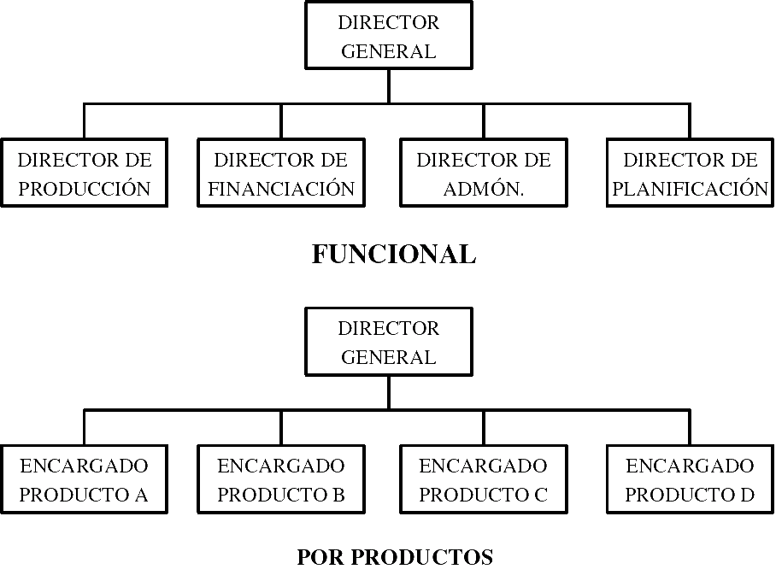
      - All these organization charts, and the following ones, are linear since they represent, in one way or another, the hierarchical structure of the organization.
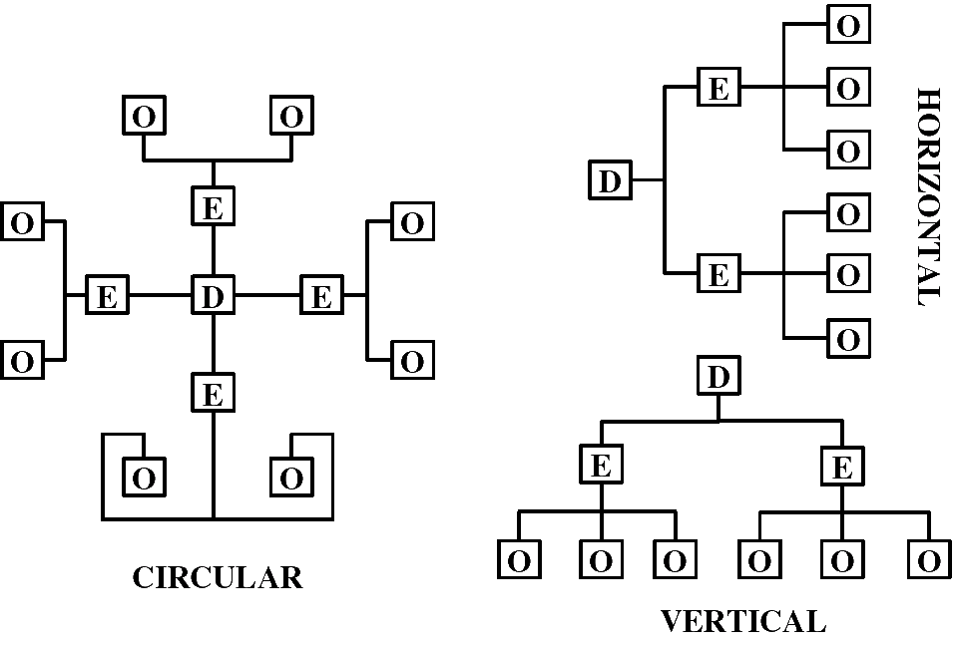
    - Departmentalization.-
      - Definition of departmentalization.- It’s dividing a company into different departments
      - Most common forms of departmentalization.-
        - By functions.-
          - Production, financing, administration, etc.
          - It is used in manufacturing companies since they need specialization
        - Geographic.-
          - Central departments direct the various branches in those matters that are their own.
          - It’s used in commercial and service companies that work in different geographical areas
        - By clients.-
          - Divisions for: large companies, shops, workshops, professionals, individuals
          - It’s used in companies that treat different types of clients
      - Other forms of departmentalization.-
        - By products.- Product A, product B, product C
        - By processes.- According to the phase of the assembly line
        - Matrix structure.-
    - New trends in the organization.-
      - The matrix structure.-
        - It is a form of departmentalization where a dual command structure is combined
        - The main drawback lies in the conflicts that dual leadership can cause
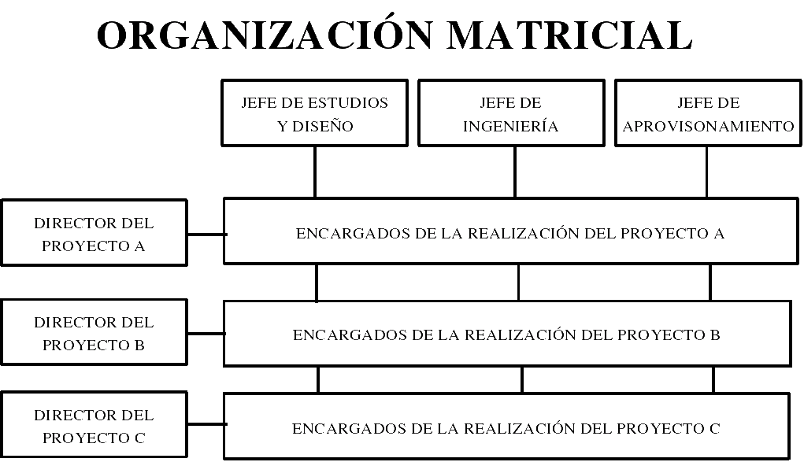
      - Strategic business units.-
      - Large companies divide their activities into smaller ones called UEN.
      - For example, RENFE: Cercanías, Long Distance, Goods, etc.
- FORMAL AND INFORMAL GROUPS.-
  - Differences between the formal organization and the informal organization.-
    - Origin.- The formal one is designed by those responsible for it; the informal arises from spontaneous relationships between workers
    - Objectives.- Those of the formal have been previously planned to achieve the aims of the company; in the informal, on many occasions, the objectives respond to personal needs
    - Structure.- In the formal it is hierarchical; the informal crosses the hierarchical lines of the formal
    - Authority.- In formal terms, authority is clearly defined; in the informal, authority is normally exercised by charismatic leaders
    - Graphic representation.- The formal has and the informal hasn’t
    - Duration.- The change of the formal structure is usually a planned and constant process; while the relationships between workers in the informal organization tend to vary frequently according to their interests
    - Purpose.- The formal purpose is to achieve the objectives set; the informal one is intended to transmit information, create rumors or gather opinions and ideas from the group

- THE MANAGEMENT FUNCTION.-
  - Basic functions of the management process; management levels.-
    - Direction and management: leadership styles.-
      - Definition of direction.- It is the government of an entity, with broad decision-making capacity and a vision of the company as a whole
      - Definition of administration.- It’s the set of tasks necessary for a plan to be executed. Has a partial and subordinate decision-making capacity to management
      - Definition of management.- It’s an activity that encompasses the previous two
      - Basic functions of the management process.-
        - Planning
        - Organization
        - Management and
        - Control
      - Management levels.-
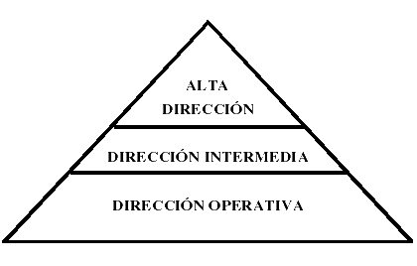
  - Authority, centralization and decentralization.-
    - Types of companies according to the management style.-
      - Companies in which power is concentrated in a few hands, tend to have authoritarian and highly centralized directions
      - Companies with different centers of power tend to have less authoritarian, more democratic and more decentralized directions
    - Types of companies from an operational perspective.-
      - Centralized companies, in which a good number of their activities are concentrated in common departments for the entire company
      - Decentralized companies, in which each department enjoys a lot of autonomy and there’re few common departments for the entire company
    - Disadvantages of centralization and decentralization.-
      - Too strong centralization leads to overly authoritarian leadership
      - Very strong decentralization can lead to lack of coordination
  - Delegation of authority.-
    - Reasons for delegating authority.-
      - Company growth.- Since, otherwise, the upper levels of the company would find themselves overworked
      - Difficulties in exercising centralized command.- For companies that have geographically widely dispersed activity centers
      - Democratic management styles.- There’re managers who prefer to delegate because they think that that way the company can work better
      - Staff motivation policies.- The person to whom authority is delegated feels motivated
    - Principles to achieve an effective delegation.-
      - Clearly define the tasks and functions assigned to each person who receives delegated authority
      - Set clear and precise goals
      - Give the appropriate means to be able to exercise the authority received
      - Establish adequate control criteria
      - Adopt a policy of incentives and sanctions that reinforces the actions of those who exercise delegated authority
    - Management by objectives and participatory management by objectives.-
      - Definition of management by objectives.- It’s one that establishes goals in the different areas of the company, assigning those responsible for their execution
      - Management modalities by objectives.-
        - Management by objectives with zero participation.- The management imposes the objectives. It’s typical of centralized companies. Autocratic leaders make decisions without consulting their subordinates
        - Management by objectives with consultative participation.- The management consults those responsible for execution and decides the objectives to be met.
        - Participatory management by objectives.- Those responsible for execution set the objectives for themselves through negotiation with the management. It’s the best
      - Conditions for the success of management by objectives.-
        - Management by objectives has to be applied in a general way to the entire organization
        - Management by objectives has to ensure coherence between the various functions of the organization
        - The objectives have to be encrypted, precise, written and measurable
        - The objectives have to be realistic, achievable, although difficult
        - The objectives have to be defined in a participatory manner and should serve to evaluate people
        - The objectives have to be reviewable
  - Levels of organization and managerial breadth.-
    - Definition of managerial breadth or direction angle.- It’s the number of employees that can directly coordinate, supervise and control a managerial position
    - How to reduce the managerial breadth? .- For this it’s necessary to increase the number of hierarchical echelons
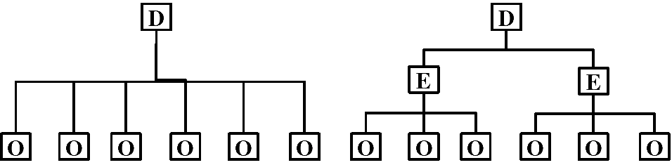
    - Example.- The director of the company on the left has greater managerial breadth since he must coordinate six employees. The director of the company on the right should only directly coordinate two team leaders each and each team leader coordinates three employees
    - Advantages of reducing managerial breadth.-
      - Greater contact between managers and subordinates
      - As there are more levels, an internal promotions policy can be adopted that motivates staff
    - Disadvantages of reducing managerial breadth.-
      - Possible interference in upward and downward communication (since the information must pass through more people to reach its recipient)
      - Structures with many hierarchical levels tend to be more expensive since the workforce tends to be artificially increased
  - Committees and commissions.-
    - Definition of commission and committee.- It’s a group of people in charge of dealing with a specific problem or several within an entity
    - Classes of committees or commissions.-
      - According to the periodicity of the meetings.-
        - Permanent committees.- They meet with a fixed periodicity
        - Circumstantial or eventual committees.- They meet to deal with a temporary problem and once resolved they dissolve
      - According to the ability to impose or not their decisions to the organization.-
        - Executive committees.- They have the capacity to impose their decisions on the organization. They’re made up of the directors of the company
        - Advisory committees.- They give information to managers so that they’re the ones to decide. These are committees of a staff nature
      - As established officially or spontaneously.-
        - Formal committees.- They’re officially established within the company structure. For example, Secondary Education Institutes must have a Coexistence Commission and an Economic Commission
        - Informal committees.- They arise spontaneously. For example, organizing a party to a colleague who is retiring
    - Reasons for the formation of commissions or committees.-
      - Count on the opinion of several people.-
      - Fear of delegating too much authority to one person.- Since they can abuse their power
      - Coordination of plans and policies.-
      - Improve information.- Allows managers to inform subordinates and obtain information from them
      - Staff motivation.- The person who has been chosen to be part of a commission feels important
  - Management and leadership models.-
    - Groups in the company and leadership.-
      - Group concept.- It’s a group of people united by a series of links and by a common organization, who share a series of basic values
      - Relations between the components of a group: leadership.-
        - Dependency relationships.- Some members seek psychic protection from others
        - Pairing relationships.- The components of a group tend to associate in pairs
        - Leadership relationships.- One person (the leader) influences the rest of the group members
      - Work teams, synergy and motivation effects.-
        - When there is cooperation and there is no competition, a work group becomes a true team and the synergy effect occurs
        - The synergy effect is that a team achieves more than the sum of what all the components would have achieved individually
  - Theories about leadership.-
    - Theory X and theory Y of McGregor.-
      - Distinguish two types of people:
        - Theory X.- Those who don’t want to work or have ambitions, and
        - Theory Y.- Those who want to work and have ambitions
      - Leadership styles.-
        - Authoritarian.- For managers who maintain theory X
        - Democratic and delegative.- For those who maintain theory Y
      - The best performing companies apply the second of the theories
      - Theories X and Y are extreme cases. Most companies will be somewhere in between
    - Fiedler's theory. Task-oriented or person-oriented leadership.-
      - Distinguish two types of managers.-
        - Those oriented towards the task.- It’s more important to them to finish the work in the scheduled time than to solve the personal problems of their subordinates
        - Those oriented towards the person.- They care more about solving the personal problems of their subordinates than finishing the work on time.
      - Leadership styles.-
        - Poor management.- Has no interest in people or the task (it is the worst of the styles)
        - Country club management.- The main interest is for people (the work environment is very pleasant and, therefore, high levels of production can be achieved)
        - Midway direction.- Consideration of both people and tasks is balanced
        - Direction to the task.- The main interest is for the task (it is typical of quite authoritarian leaders)
        - Team management.- You have a lot of interest in people and tasks (you work as a team, in quality circles)
          - An example of quality circles is the case of Toyota, where groups of about six people take charge of all the steps of the manufacture of a vehicle meeting among themselves to distribute the work and seek improvements.
      - Graph.-

    - Hersey Blanchard theory. Situational leadership.-
      - Think that the leadership style to choose depends on the maturity of the people considered under two aspects:
        - Motivation.- Wanting to do the job
        - Capacity.- Knowing how to do the job
      - Leadership styles.-
        - Sort.- For people who are neither motivated nor trained (neither want nor know)
        - Delegate.- For people who are motivated and trained (want and know)
        - Participate.- For people who are not motivated but are trained (they don't want to but they know)
        - Persuade and support.- For people who are motivated but not trained (want but don’t know)
  - Strategy concept: its elements and levels.-
    - Strategy concept.-
      - It is the general orientation of the way in which the company will act to achieve its general objectives
      - The strategy is based on achieving a superior advantage over competitors in an important aspect (competitive advantage)
    - Definition of competitive advantage.- It’s the value that a company is capable of creating for its buyers. It’s the disbursement that buyers are willing to make for the products or services that a company provides them (eg home delivery of purchases from a supermarket)
    - Classes of strategies.-
      - Cost leadership.- Achieve the lowest costs
      - Differentiation.- Make your product or service stand out from others through quality improvement, special guarantees, brands, etc.
      - Segmentation.- Offer each group of buyers the product they want
- THE MOTIVATION.-
  - Definition of motivation.- It is what drives us to want to do things
  - Incentives that affect work motivation.-
    - The money.-
      - It serves to satisfy the needs of purchase and the needs of status (social position)
      - For money to be a motivating factor, the worker must perceive that the company recognizes his efforts and enthusiasm
    - Expectations.- If you have the possibility of moving up, you’re motivated, if you see that you can’t do it, you’re demotivated
    - Participation in work.- Especially for creative and well-prepared people
    - Equitable treatment.- People who are at a certain level should be treated in the same way, without discrimination
    - Recognition.- It’s convenient to encourage them both morally and materially
  - Main theories about motivation.-
    - Maslow's scale of needs.- It classifies human needs in the following five levels, from bottom to top, which must be satisfied progressively:
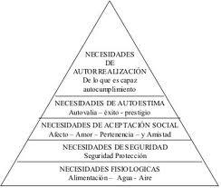
      - First.- Basic physiological needs (eating, dressing, lodging, etc.)
      - Second.- Security needs (permanent contracts, solvent companies, protection against old age, etc.)
      - Third.- Social needs (occupy a consolidated position within the group and be accepted by it)
      - Fourth.- Self-esteem needs -social needs II- (the achievement of the objectives that the person has proposed within the company)
      - Fifth.- Self-realization needs (achieve the ideals proposed at a general level)
    - Herzberg's bifactorial theory: job enrichment.- Considers that, with regard to work motivation, there are two groups of factors:
      - The hygienic ones.- That they don’t produce motivation properly so called but whose lack generates dissatisfaction in the workforce (the physical work environment, salary, job stability, etc.)
      - The motivational ones.- Directly promote to work better (promotion in the company, the possibility of expanding knowledge and professional development, being responsible for a position or a task, etc.)
    - Vroom's expectation theory.-
      - It considers that the motivation of a person to achieve a goal is determined by two factors: the value placed on that goal and the expectation of being able to achieve it
      - According to this theory, the motivation of a person grows the greater the value that this attaches to the goal they want to achieve and the more possibilities they have of achieving it
- THE COMMUNICATION.-
  - Concept of communication.- It’s the exchange of information between people
  - Elements in the information.-
    - The message.- It’s the news object of the transmission (ETA attack in Madrid)
    - The medium.- It’s the form or technology used for the transmission (written press, radio, television, etc.)
    - The support.- It’s the vehicle used (typewriter, computer program, etc.)
    - Language.- It’s the set of symbols and rules that allow to elaborate an understandable message (Spanish, English, symbols, etc.)
    - The issuer.- He is the one who elaborates the message with the intention of making it known (TVE)
    - The receiver.- It’s the recipient of the message (who is watching the news)
  - Principles of communications.-
    - Principle of clarity.- Communications must use a language and a structure known to all the elements of the system.
    - Attention principle.- The receiver must distribute his time in a convenient way so that he can give the necessary interest to the different information he receives
    - Principle of integrity.- It consists of the transmission of information through middle managers, avoiding its "bridging" and the consequent loss of authority.
    - Principle of the strategic use of the informal organization.-
  - Conventional means of communication.-
    - Verbal communication.-
      - Advantages.- In general: speed, a lot of response and a lot of gestural communication
      - Disadvantages.- Lack of evidence and, in some cases, sterile meetings
      - Forms and effects of verbal communication.-
        - Interviews.- Two people. A lot of response and a lot of gestural communication
        - Meetings.- Small number of people. Medium response and medium gestural communication
        - Lectures and macro-meetings.- Large groups convened by the management. Poor response and poor gestural communication
        - Telephone.- Normally two people. Lots of response and no gestural communication
    - Written communication.-
      - Advantages.- Existence of evidence and the possibility of sending extensive documents
      - Disadvantages.- Normally slowness, the time required to read the messages and answer them, the accumulation of papers, etc.
  - Communication flows.-
    - Descending.- It serves for the company to transmit the information it deems appropriate
    - Ascending.- It helps the company know what its employees think
    - Lateral.- It serves to coordinate the different departments of the company. Could be:
      - Horizontal.- Between departments of the same hierarchical level
      - Diagonal.- Between departments of different hierarchical level
  - Communication barriers and failures.-
    - Not knowing how to listen
    - Mistrust
    - Information overload
    - Hear only what interests you
    - Default attitude
    - Poor selection of the moment to establish communication
  - Stages in the elaboration of the information.-
    - Data Collect.-
    - Debugging.- It consists of eliminating superfluous data and errors
    - Storage.- It consists of looking for an adequate support to retain the information, usually it is a computer program
    - Process.- It’s about obtaining the desired results from the collected data; it’is usually done by computerized procedures
    - Distribution of the information prepared.-
  - Information systems to use.-
    - For primary information.- Internal reports or orders will be used
    - For secondary information.- Telematics will be used (or integrated use of computer systems, programs and telephone network)
    - For administrative management.- Other more traditional systems will be used, such as fax, messaging, correspondence, etc.
  - Main characteristics of the manual treatment of information.-
    - Existence of human resources assisted or not by machines
    - Little agility in accessing the information to be consulted
    - Limitation of effectiveness to personal capacity
    - Causes fatigue
    - Requires one-person information systems
    - It’s possible when one person does all the work
    - If the number of workers on the information increases, it will be necessary a previous task of assigning responsibilities and then a work of compilation or sharing
  - Main characteristics of the mechanized treatment of information.-
    - It appears when a certain business dimension is exceeded
    - There are two approaches to mechanization:
      - Direct formula.- By simple transfer from manual to mechanical processes
      - Integration.- The data is registered only once and can be used for different administrative and accounting processes
    - It requires computerized treatment through the use of computer equipment
    - Planning is necessary to allow the expansion of IT facilities
    - Requires qualified personnel to use these media
- CONTROL CONCEPT AND PROCESS.-
  - Control concept.- Control is to watch that everything happens according to plan
  - Process.-
    - Set standards of results relative to some future period of time
    - Measure the actual results of the period
    - Compare actual results with expected standards
    - Determine reasons for differences, if any
    - Take the appropriate measures
  - Types of control.-
    - Management.- It has a global character, based on the levels of responsibility and the degree of fulfillment of the defined objectives
    - Operations.- Measures the efficiency in production processes
    - Budgetary.- Compare economic forecasts with reality
  - Who should carry out the control?.- The management, although it can delegate the same in control departments of a staff nature

- FUNCTIONAL AREAS OF THE HUMAN RESOURCES ADMINISTRATION.-
  - Definition of human resources.- In business administration, the work contributed by all the employees or collaborators of that organization is called human resources. But the most frequent thing is to call this the function that is responsible for selecting, hiring, training, employing and retaining the organization's collaborators. These tasks can be carried out by a specific person or department (Human Resources professionals) together with the managers of the organization.
  - Basic objective.- The basic objective pursued by the Human Resources (HR) function with these tasks is to align HR policies with the organization's strategy, which will allow the strategy to be implemented through people.
  - Areas.- Generally, the Human Resources function is composed of areas such as Recruitment and Selection, hiring, training, induction of personnel and their permanence in the company. Depending on the company or institution where the Human Resources function operates, there may be other groups that carry out different responsibilities that may have to do with aspects such as the administration of the employee's payroll, the management of relations with unions, etc.
  - Staff needs planning concept.-
    - Planning personnel needs is to foresee what workers we will need at each level of the company in the short, medium and long term
    - If companies don’t plan their short, medium and long-term staffing needs, they may encounter the following problems:
      - The rush doesn’t allow you to select the truly suitable people
      - It doesn’t allow adequate career planning for new candidates, consequently wasting the opportunity to use expectations as a source of motivation
      - The emergencies cause many workers to be hired, oversizing the workforce This will cause layoffs in the future that will not promote a good working environment
  - Steps to take to achieve an adequate adaptation to the job position.-
    - Describe the characteristics of the position you want to fill
    - Describe the professional profile of the person who should occupy it (youth, physical appearance, sex, etc.). For this we can use profesiograms (graphic representations of the requirements or characteristics of a job)
- RECRUITMENT AND STAFF SELECTION.-
  - Personnel recruitment concept.- It’s hiring the necessary staff
  - Recruitment sources.-
    - Internal selection.- It consists of offering the job to people who are already part of the company
      - Advantage.-
        - Motivation as it allows promotions
        - Possible promotions promote the training of workers, which means an investment in human capital
        - Employees are known thereby reducing the risk of not choosing the right one
        - It’s faster and cheaper than external selection
        - It allows to take advantage of the investments in personnel training that the company has made
        - The adaptation phase of the candidate is reduced
      - Disadvantages.-
        - Doesn’t allow the entry of new ideas
        - Tensions can arise between people in the company with more merits to occupy the position in question
        - It isn’t always possible, for example if it is a staff extension
    - The external selection.-
      - Advantage.-
        - Allows entry of new ideas
        - Possibility of rejuvenating the staff
      - Disadvantages.-
        - Employees aren’t known so there is a risk of not choosing the right one
        - The cost of conducting a serious recruitment process and its slowness
  - The selection of personnel.-
    - Personnel selection concept.-It’s to choose the right workers for each job
    - The process of external selection of personnel.-
      - Location of the source of human resources.- In universities, schools, institutes, employment offices, etc.
      - Initial contact – Job application and curriculum vitae
      - Selection tests. Classification.-
        - Knowledge tests.- Resolution of a practical case, typing test, etc.
        - Psychotechnical tests.-
          - Intelligence tests.-
            - The DAT or differential aptitude test.- Evaluates verbal reasoning, numerical aptitude, abstract reasoning, etc. For instance: ___ it’s a masculine, as a woman it is a ___
            - The PMA or test of primary mental aptitudes.- It evaluates the verbal comprehension, the numerical calculation, the verbal fluency, etc. For example: Write words that start with P
          - Personality tests.-
            - Personality questionnaires.- They question the subject about opinions, preferences, foreseeable behavior, etc.
            - Projective test.- The subject indicates what a certain spot suggests to him, draws a figure, etc. Subsequently, the specialist tries to guess the personality of the individual according to what he has answered or painted
          - Vocational interest tests.- They’re done to find out the satisfaction or rejection produced by the work to be performed
        - The interviews.-
          - Objectives to be pursued.-
            - Confirm the applicant's profile
            - To clear doubts
            - Observe the reactions of the individual and the way they develop
            - Inform the candidate about the characteristics of the company, the job position, the salary, etc.
          - Types of interviews.-
            - Planned
            - Free
            - In tension
            - Multiple
            - Group
          - Behavior guidelines of the interviewee.-
            - Have a correct physical presence
            - Puntuality
            - Greet politely without nervousness and say goodbye anyway
            - Neither cross legs nor sit in front of chairs
            - Direct look at the interviewer
            - Clear answers without hesitation
  - The reception phase.- For the adaptation to be as complete and quick as possible, clear instructions must be given on the content of the entrusted work, on the hierarchical relationships, objectives that the company has set, etc.
- WORK CONTRACT. TYPES.-
  - Wage concept.-
    - Concept.- It is the totality of the economic perceptions that the worker receives from the employer for the professional provision of his labor services (remunerating the effective work or the rest periods computable as work)
    - Composition.- The wage is made up of Base Wage and Wage Supplements (depending on a series of circumstances related to the work or the worker)
    - Documentation.- It must be documented in a payroll or wage receipt
    - Minimum wage.- It’s the minimum remuneration that a worker must receive. The Government establishes it annually
  - Concept of employment contract and types of contracts.-
    - Concept of Work Contract.- It’s the agreement by virtue of which a person, the worker, voluntarily agrees to provide his services within the scope of organization and direction of the employer who in turn is obliged to pay the worker a remuneration for the services provided
    - Types of contracts.-
      - Indefinite contracts.- In this contractual modality, the employer and the worker commit themselves for an indefinite period of time.
      - Training contracts.- In this modality, the employer undertakes, in exchange for the provision of services to the worker, to give him theoretical and practical training
      - Part-time contracts.- In this modality, the worker will be understood to be hired part-time when he provides services for a number of hours a day, a week, a month or a year, less than that considered as usual, in the activity, in those periods of time
      - Fixed-term contracts.- They’re hired temporary, that is, not for an indefinite period
      - Contracts under measures to promote employment.- These contracts are intended to facilitate the stable placement of unemployed workers and temporarily hired employees.
      - Contracts of making available.- They are those that are celebrated with Temporary Employment Companies whose activity consists of making available to a user company, on a temporary basis, workers hired by it
- HEALTH AND SAFETY AT WORK. WORKPLACE HAZARD PREVENTION.-
  - Main obligations of the employer in matters of Workplace Hazard Prevention.-
    - Guarantee the Safety and Health of the workers
    - Carry out the prevention of workplace hazards by adopting whatever measures are necessary
    - Assess workplace hazards
    - Plan preventive action based on the results of the risk assessment
    - Ensure that the means of work guarantee the safety of workers
    - Provide workers with adequate means of personal protection for the work to be carried out when risks can’t be sufficiently avoided or eliminated.
    - Properly inform workers about the existing risks, the applicable prevention measures and activities and the emergency measures adopted
    - Consult workers and allow their participation in all matters that affect safety and health at work
    - Guarantee that each worker receives adequate training in preventive matters
    - Inform and take action when workers may be exposed to a serious and imminent risk
    - Guarantee periodic medical surveillance of workers' health
  - Main rights of the employer in matters of Workplace Hazard Prevention.-
    - Require workers to comply with the obligations corresponding to them in this matter
    - Require workers to comply with workplace health and safety regulations
    - Be part, where appropriate, of the Workplace Health and Safety Committee, either directly or through their representatives
  - Main obligations and rights of workers in the area of Workplace Hazard Prevention.-
    - Ensure their safety and health by complying with the established prevention measures
    - Properly use machines, tools and materials
    - Correctly use the means of individual protection provided by the company
    - Don’t modify or annul, and use correctly, the safety devices
    - Immediately report any situation that in your opinion involves risks
    - Collaborate with the employer so that he can guarantee safe working conditions
    - Receive adequate training in preventive matters
    - Effective workplace health and safety protection
    - Receive information about the existing risks, the applicable protection measures and activities and the emergency measures adopted
    - Be consulted and participate in all matters that affect safety and health at work
    - Receive adequate information on preventive matters
    - Be informed when they may be exposed to a serious and imminent risk
    - Periodic monitoring of your health status based on the risks inherent to the job
    - Be part, where appropriate, of the Workplace Health and Safety Committee, through their representatives
    - Protection of maternity and minors
    - The protection of workers who are especially sensitive to certain risks
    - Use adequate and duly protected means of work
    - To be provided with means of personal protection appropriate to the task and the risks it entails, when the risks derived from said task haven’t been sufficiently avoided or reduced
  - Responsibility and sanctions in the area of Workplace Hazard Prevention.- The employer is the only possible recipient of the responsibilities, being able to reach the sanctions amounts of up to €600,000
  - Preventive activity in the company.-
    - Early preventive action.-
      - Avoid risks
      - Evaluate the risks that can’t be avoided
      - Combat the risks at source
      - Adapt work to the person, in particular with regard to the design of jobs, as well as the choice of equipment and methods of work and production to lessen monotonous work and repetitive and reduce the effects of it on health
      - Take into account the evolution of technology
      - Substitute the dangerous for what has little or no risk
      - Plan prevention, seeking a coherent set that integrates technique, work organization, working conditions, social relationships and the influence of environmental factors at work
      - Adopt measures that put collective protection before individual protection
      - Giving appropriate instructions to workers
    - Phases of the implementation of preventive activity in the company.-
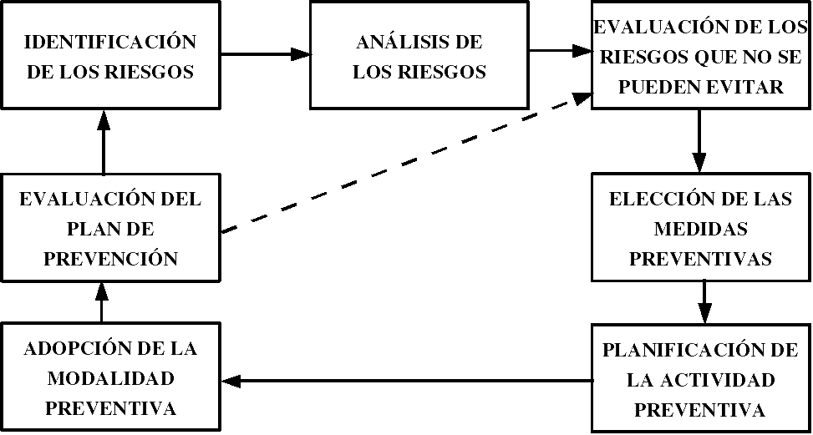
    - Classification of the most common workplace hazards.-
      - Falls of people or objects
      - Bumps or cuts by objects or tools
      - Entrapment
      - Physical or mental fatigue
      - Exposure to extreme ambient temperatures, harmful substances or radiation
      - Thermal, electrical or contacts with caustic and/or corrosive substances
      - Explosions
      - Fires
      - Accidents caused by living beings
      - Noise
      - Vibrations
      - Illumination
      - Dissatisfaction
    - Collective protection systems.-
      - Protections (shells, covers, screens, etc.)
      - Railings
      - Visors
      - Platforms, double mesh or wooden tops
      - Safety nets
      - Differential switches
      - Safety signs
    - Individual Protection Equipment.-
      - Helmets
      - Screens and glasses
      - Earmuffs, earplugs or cottons
      - Masks
      - Gloves, mittens, thimbles, etc.
      - Suitable footwear
    - Hazard assessment.-
      - What is hazard assessment? .- It’s to obtain information on the risks that haven’t been avoided in order to decide what preventive measures should be adopted
      - What should be evaluated? .-
        - The existing or planned working conditions in each position
        - The possibility that the worker who occupies it or is going to occupy it is especially sensitive, due to his personal characteristics or known biological state, to any of these conditions
      - When should the Hazard Assessment be updated? .-
        - In general, when there is any modification that affects the work (new machines, new equipment, the incorporation of a worker with a disability, etc.)
        - Determined by a specific provision
        - Health damage has occurred
        - The ineffectiveness of the preventive measures adopted is proven
        - It’s agreed with the workers or their representatives
    - Planning of preventive activity.-
      - Contents to take into account in the implementation of a Prevention Plan in the company.-
        - Declaration of the Preventive Policy and definition of the objectives and goals to be achieved
        - Establishment of the roles and responsibilities of each person in the organization
        - Establishment of the preventive organization modality, and allocation of human, material and economic resources, to achieve the proposed objectives
        - Planning proper said; that is, specify what has been expressed in the points relating to the rights and duties of workers and employers. For instance; one of the employer's duties is to provide training on Workplace Hazards Prevention to his employees; well, now it will be necessary to indicate what courses are going to be given, where, when, with what frequency, etc.
    - Modalities of organization of resources for preventive activities.-
      - Personal assumption by the employer of the preventive activity.-
        - The company must have less than six workers
        - The actions carried out by the company shouldn’t be considered risky
        - The employer, on a regular basis, must work in the workplace
        - The employer must have the necessary capacity and quality
        - Health surveillance, as well as other preventive activities not personally assumed by the employer, must be covered by any of the other organizational modalities
      - Designation of workers.-
        - The preventive activities that can’t be covered in this way must be developed through one or more prevention services of our own or others.
        - For the preventive activity, the appointment of workers won’t be mandatory when the employer assumes it personally, has resorted to his own prevention service or a third party service
        - Workers must have the capacity corresponding to the functions to be performed
        - The number of workers and the resources assigned must be as necessary
        - Designated workers can’t suffer any damage for this reason and will have some guarantees that the workers' representatives have
      - Own and joint prevention services.-
        - Own prevention services.-
          - The company must have more than 500 workers
          - Also those that carry out risky activities and have between 250 and 500 workers
          - When so decided by the labor authority, although you may choose a third party service
          - Activities that don’t carry out their own service may be arranged with third-party services
        - Joint prevention services.-
          - Those who carry out their work simultaneously in the same center
          - By collective bargaining or through agreements
          - Those from the same sector that are in the same industrial estate or limited area
          - Activities that don’t carry out their own service may be arranged with third-party services
      - Third-party prevention services.-
        - When should the employer to have an External Prevention Service? .-
          - When you can’t designate one or more workers or create your own
          - When required by the Labor Authority
          - When the employer or the service itself has only partially assumed prevention
        - Requirements that Entities that act as Third Party Prevention services must have.-
          - Have the minimum organization, staff, equipment and facilities to carry out this activity
          - Establish a guarantee that supports your eventual liability
          - Not having any connection with the concerted company that could affect their independence
          - Have the approval of the Health Administration in matters of health
          - Be accredited before the Labor Administration
        - Minimum content of the Preventive Activity agreement with an External Prevention service.-
          - Identification of the entity that acts as an external prevention service
          - Identification of the recipient company and its work centers
          - Indicate the preventive activity to be carried out
          - Indicate the health surveillance activity to be carried out, if applicable
          - Economic conditions
    - What companies are required to undergo a prevention audit? .-
      - All those who haven’t arranged all their preventive activity with an External Prevention Service
      - Companies with up to six workers, whose activity is not included in Annex I of RD 39/97, in which the prevention functions have been assumed by the employer or by one or more designated workers, and haven’t accepted the provided in Annex II of said RD
  - The consultation and participation of workers in the preventive activity of the company.-
    - The Prevention Delegates.-
      - Number of Prevention Delegates appointed by and among staff representatives

Number of workers | Number of Prevention delegates
Less than 50 | 1
From 50 to 100 | 2
From 101 to 500 | 3
From 501 to 1,000 | 4
From 1,001 to 2,000 | 5
From 2,001 to 3,000 | 6
From 3,001 to 4,000 | 7
More than 4,000 | 8

      - Competences of the Prevention Delegates.-
        - Collaborate with the management of the company in the improvement of preventive activity
        - Promote and encourage worker cooperation in prevention
        - Be consulted by the employer on preventive matters
        - Monitor and control compliance with the regulations on prevention
        - Those attributed to the Health and Safety Committee when the company doesn’t have it
    - The Health and Safety Committee.-
      - Constitution.- It will be constituted in all companies or work centers that have 50 or more workers
      - Composition.- There must be the same number of representatives of the workers as the employer
      - Competences.-
        - Participate in the development, implementation and evaluation of Risk Prevention plans and programs
        - Promote initiatives on methods and procedures, propose improvements in working conditions and correction of existing ones
      - Faculties.-
        - Know the preventive situation of the company
        - Know the documentation on working conditions
        - Know and analyze the damage caused to the health of workers
      - They can participate once but without vote.-
        - Union Delegates
        - The company's Prevention Technicians
        - Anyone to inform, at the request of the party
      - Meetings frequency.-
        - Quarterly
        - At the motivated request of one of the parties
- CONFLICTS OF INTEREST AND THEIR TRADES OF NEGOTIATION.-
  - Ways to overcome intragroup conflicts (within the group) .-
    - Elimination of the opposition.- By layoff, forced transfer or submission. It isn’t an inclusive or positive solution
    - Search for consensus with the opposition.- It’s an inclusive and positive solution but it doesn’t eliminate the causes of the conflict, which remain latent
    - Integration, search for new alternatives.- For example, if the struggle is established to gain access to the department's management, a solution could be to restructure the department by establishing heads of functions and external coordination
  - Intergroup conflicts (with other groups) .-
      - The different departments want to stand out from the rest
      - To solve this problem, the formal organization of the company must be well designed and the objectives and functions well defined by senior management, who must try to create a climate of collaboration.

More information about PERT
      - General view.-
        - Definition.- The Technical Review and Evaluation Program (or Project), commonly abbreviated PERT, is a model for project management designed to analyze and represent the tasks involved in completing a given project. It’s commonly used in conjunction with the critical path method or CPM.
        - Minimum time.- PERT is a method of analyzing the tasks involved in completing a given project, especially the time needed to complete each task, and identifying the minimum time needed to complete the total project.
        - History.- PERT was developed primarily to simplify planning and scheduling of large and complex projects. It was developed by the United States Navy Office of Special Projects in 1957 to support the United States Navy Polaris nuclear submarine project. It could incorporate uncertainty by making it possible to schedule a project while the details and durations of all activities were not precisely known. It’s more of a more event-oriented technique than one oriented to start and finish, and is used more in projects where time, rather than cost, is the most important factor. It’s applied to Research and Development projects at a very high rate. large scale, unique, complex,
        - Scientific Direction.- This project model was the first of its kind, a resurgence for scientific direction, founded by Frederick Taylor (Taylorism) and later refined by Henry Ford (Fordism). The DuPont company's critical path method was invented around the same time as PERT.
      - Conventions.-
        - Number.- A PERT chart is a tool that facilitates decision making. The first draft of a PERT chart will number its events sequentially to allow for later insertion of additional events.
        - Links.- Two consecutive events on a PERT chart are linked by activities, which are conventionally represented as arrows.
        - Sequence.- The events are presented in a logical sequence and no activity can begin until its immediately preceding event is completed.
        - Appropriate.- The planner decides which milestones should be PERT events and also decides their appropriate sequence.
        - Pages.- A PERT chart can have multiple pages with many sub-tasks.

  - More information about the Wilson Model.-
    - Economic order quantity.- It’s the inventory level that minimizes total inventory maintenance costs and order costs. It is one of the oldest classic models of production programming. The framework used to determine this order quantity is also known as the Wilson EOQ Model or Wilson Formula. The model was developed by FW Harris in 1913, but RH Wilson, a consultant who applied it extensively, has been given the honor of thoroughly analyzing it early.
    - General view.-
      - Constant.- Assume that demand for a product is constant throughout the year and that each new order is fully delivered when inventory reaches zero. There is a fixed cost charged for each order placed, regardless of the number of units ordered. There is also a cost of ownership or storage (sometimes expressed as a percentage of the cost of purchasing the item).
      - Optimum.- We want to determine the optimal number of units of the product to order so that we minimize the total cost associated with the purchase, delivery and storage of the product
      - Parameters.- The parameters required for the solution are the total demand for the year, the purchase costs for each item, the fixed cost to place the order and the storage cost for each item per year. Note that the number of times an order is placed will also affect the total cost, however, this number can be determined from other parameters.
    - Underlying assumptions.-
      - The order cost is constant.
      - The demand rate is constant
      - Delivery time is fixed
      - The purchase price of the item is constant, e.g. No discount available
      - Replenishment is done instantly, the entire batch is delivered at the same time.
      - EOQ is the order quantity, so that the order costs + the holding costs find their minimum. (A common misunderstanding is that the formula tries to find where these are equal)
    - Variables.-
      - Q = order quantity
      - Q * = optimal order quantity
      - D = quantity of annual demand for the product
      - P = purchase cost per unit
      - S = fixed cost per order (not per unit, in addition to unit cost)
      - H = annual cost of ownership per unit (also known as cost of ownership or cost of storage) (warehouse space, refrigeration, insurance, etc. usually not related to unit cost)
    - The total cost function.-
      - Minimum point.- The EOQ formula finds the minimum point of the following cost function:
      - Total cost = purchase cost + order cost + possession cost
      - Purchase cost: This is the variable cost of the goods: unit purchase price x quantity of annual demand. This is P x D
      - Order cost: This is the cost of placing orders: each order has a fixed cost S, and we need to order D/Q times per year. This is S × D/Q
      - Cost of ownership: the average quantity in stock (between fully replenished and empty) is Q/2, so this cost is H × Q/2
      - TC= PD + DS: Q + HQ: 2
      - Equalize costs.- To determine the minimum point of the total cost curve, place the order cost equal to the cost of ownership:
      - DS: Q = HQ: 2
      - Solving for Q gives Q * (the optimal order quantity):
      - H: 2 = DS: Q2
      - Q2= 2DS: H
      - Q * = sqrt (2DS: H)
      - Therefore: Notice that interestingly, Q * is independent of P; is a function of only S, D, H.
    - Example.-
      - Annual demand quantity of the product (D) = 10,000 units
      - Fixed cost per order (S) = $2
      - Cost per unit (CU) = $8
      - Cost of ownership (percentage of cost per unit) = 0.02
      - Cost of ownership per unit (H) = $0.16
      - Q * = sqrt (2DS: H) = sqrt (2 x 10,000 x 2: 0.16) = 500 units
      - Number of orders per year (based on EOQ) = 10,000: 500 = 20
      - Total cost = PD + DS: Q + HQ: 2
      - Total cost = 8 x 10,000 + (10,000 x 2): 500 + (0.16 x 500): 2
      - Total cost = $80,080
    - 1st check.- If we check the total cost for any order quantity other than 500, we will see that the cost is higher. For example, assuming 600 units per order, then:
      - Total cost = 8 x 10,000 + (10,000 x 2): 600 + (0.16 x 600): 2
      - Total cost = $ 80,081.33
    - 2nd check.- Similarly, if we choose 300 for the order quantity then:
      - Total cost = 8 x 10,000 + (10,000 x 2): 300 + (0.16 x 300): 2
      - Total cost = $ 80,090.67
    - Interest. - This illustrates that the Economic Order Quantity is always in the best interest of the entity.

  - More information about the ways to obtain primary data.-
    - Surveys.-
      - Telephone.-
        - Encourage.- Use of interviewers to encourage the people in the sample to respond, leading to a higher rate of responses.
        - Clarify.- Interviewers can increase the understanding of the questions by answering the questions asked.
        - Cost.- Fair cost efficient, depending on the local structure of charges per call
        - Large samples.- Good for large national (or international) sample frames
        - Sensitive topics.- Some potential for the interviewers' approach (eg, some people may be more willing to discuss a sensitive topic with an female interviewer than with an male interviewer)
        - Non-audio.- Can’t be used for non-audio information (graphics, demonstrations, taste/smell samples)
        - Rural areas.- Unreliable for consumer studies in rural areas where telephone penetration is low
        - Three types.-
          - traditional telephone interviews
          - computer-assisted telephone dialing
          - computer-assisted telephone interview
      - Mail.-
        - Delivered or sent.- The questionnaire can be delivered to respondents or mailed to them, but in all cases they are returned to the investigator by mail.
        - Cost.- The cost is very low as bulk postage is cheap in most countries.
        - Delay.- Long delays, often several months, before surveys are returned and statistical analyzes can begin
        - No clarification.- Not recommended for issues that should require clarification
        - Own convenience.- Respondents can do so at their own convenience (allowing them to start long surveys; also useful if they need to check records to answer a question)
        - Influence.- The interviewer can’t influence
        - Large.- A large amount of information can be obtained: some postal surveys are as long as 50 pages
        - Postal panels.- Response rates can be improved by using postal panels. The panel members have agreed to participate. Panels can be used in longitudinal designs where the same responders are surveyed multiple times
      - Online surveys.-
        - Web or mail.- They can use web page or email, the web page is preferable over email because interactive html forms can be used
        - Inexpensive.- Often inexpensive to administer
        - Fast.- Very fast results
        - Modification.- Easy to modify
        - Panels.- Response rates can be improved using online panels - panel members agree to participate
        - Password.- If there is no password protected, it’s easy to manipulate by completing multiple times to modify the results
        - Automatic.- The creation, manipulation and emission of data can be automatic and/or easily exportable in a format that can be read by a statistical analysis program.
        - Real time.- Data set created in real time
        - YouGov.- Some are incentive-based (such as Survey Vault or YouGov)
        - Younger.- They can modify samples towards a younger demographic
        - Quantitative analysis.- Often difficulty in determining/controlling the selection of probabilities, making quantitative analysis of the data difficult
        - Large scale.- Used in large scale industries.
      - Personal survey at home.-
        - At home.- Respondents are interviewed in person, at home (or at the front door)
        - Cost.- Very high cost
        - Graphics, smells.- It’s appropriate when graphical representations, smells or demonstrations are involved
        - Long.- Often appropriate for lengthy surveys (but some respondents object to allowing strangers to enter their homes for extended periods)
        - No telephone/mail.- Appropriate for places where the telephone or the mail isn’t developed
        - Response rates.- Skillful interviewers can persuade respondents to cooperate, improving response rates.
        - Partiality.- Possibilities for the interviewer's partiality
      - Personal surveys intercepting in a shopping center.-
        - Various ways.- Shoppers in shopping centers are intercepted - or are interviewed on site, or taken to a room and interviewed or taken to a room and given a self-administered questionnaire
        - Acceptable.- Socially acceptable - people feel that a shopping center is a more appropriate place to do research than in their homes
        - Partiality.- Possibilities for the interviewer's partiality
        - Fast.-
        - Manipulable.- Easy to manipulate by completing multiple times to skew results
    - Observation.- Observation is an activity consisting of receiving knowledge of the outside world through the senses, or the recording of data using scientific instruments. The term can also refer to any data collected during this activity.
    - Experimentation.- The results are observed in a laboratory environment.

  - More information on consumer panels.-
    - Definition.- Consumer Panels are a research technique to measure markets that uses the same sample of people who respond on an ongoing basis. This research technique benefits from a number of very special characteristics to be the most efficient way to measure markets and behaviors quite accurately:
      - Large size.- Using large samples with the same people who respond increases the best possible quality of information and data from the consumer panel, in both, in absolute terms and in trend.
      - Current.- Because the information is collected on a current basis, the panelists don’t need to use memory to remember their behavior.
      - Change.- As the sample is fixed, any change in behavior from one period to the next is collected as precisely as possible.
      - Supplementary information.- A range of information to supplement the basics of purchase and use is also collected from the sample. This allows the exploration of the attitudes behind the measured behaviors, and the response to the influences on them from various marketing activities.
      - Purchase and use.- It’s possible to measure both, the purchase behavior and the subsequent patterns of use. The combination of both data provides even more elements for users to understand.
      - Various methods.- The correct methodology for the task is vital. Panel members need to be able to accurately collect and record the required information, but in a form that is simple and easy to maintain their motivation on a current basis. Depending on the market, a variety of proposals including in-home barcode scanning, to collecting invoices, SMS, and web-based methods can be used to help panelists do their job as conveniently as possible.
    - Collect.- Once the data has been collected, it’s compiled into a database. Each service has a regular set of metrics that are used to observe the performance of a market and the products within it. This includes:
      - Sales and quotas (in volume and in value)
      - Price
      - Penetration (proportion of people buying)
      - Purchase weight (how much each buyer buys)
      - Loyalty (the proportion of brand buyers buying for whom only the brand counts)
      - Repetition rate (what proportion of a brand's buyers buy more than once?)
      - Purchase frequency (how often do you shop?)
    - More in-depth.- Frequently, more in-depth analysis than considering a specific piece of information and a deeper understanding can be developed:
      - Brand change
      - Demographic analysis
      - Test and replay analysis
      - Repertoire analysis
      - Large/medium/small buyers
      - New/Lost/Repeaters buyers

